This equation sheet is meant to be my recommendation for information to put on your notecard. This is NOT a list of everything you should know.
1. First law of thermodynamics
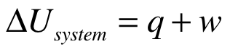
if q is positive, heat is going into system
if w is positive, work is being done on the system

2. Calorimetry

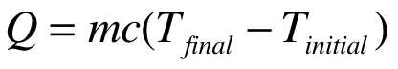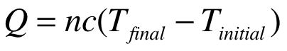

Explanation of variables (typical units are given in parentheses)
Q is heat gained or lost (J) Q is heat gained or lost (J)
m is mass of sample (g) n is number of moles (mol)
c is specific heat capacity (J/g •K) c is molar heat capacity (J/mol•K)

3. For heat exchange at constant pressure
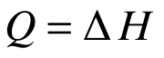

4. Enthalpy of reaction
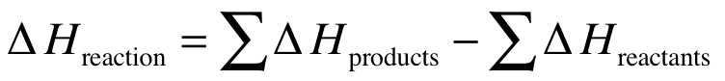

Remember to use the appropriate stoichiometric coefficients when you calculate ∆H.

You could write identical equations for ∆S and ∆G.

5. Heat capacity at constant pressure vs. heat capacity at constant volume
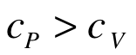
this assumes that we are considering cp and cv for the same material

6. Gibbs free energy (∆G)
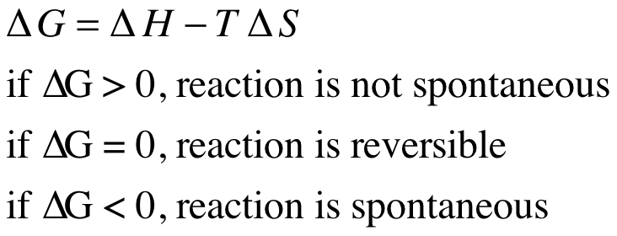

7. Entropy (∆S)
to calculate ∆S for a temperature change
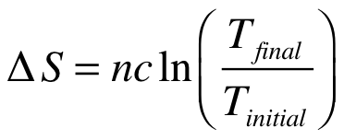
n is number of moles
c is molar heat capacity
-If we are at a constant pressure, then use cp
-If we are at a constant volume, then use cv

to calculate ∆S for a volume change (at a constant temperature)
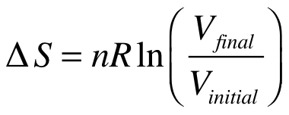
n is number of moles
R is gas constant

to calculate ∆S for a phase change
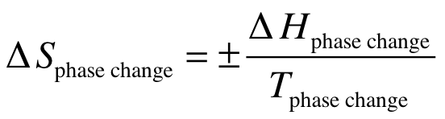
Use the plus sign if you are going from solid to liquid (melting) or liquid to gas (evaporation). Use the minus sign if you are going from gas to liquid (condensation) or liquid to solid (freezing).

8. Equilibrium constant (K)
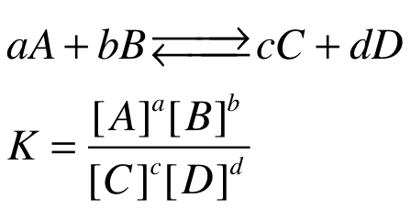

9. Relating the equilibrium constant to Gibbs free energy
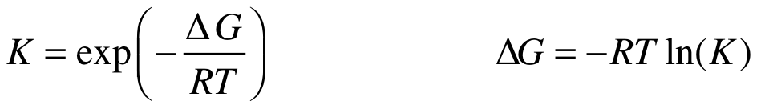
These expressions are equivalent. One is solved for K and the other is solved for ∆G.

10. Thermal expansion
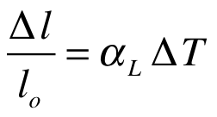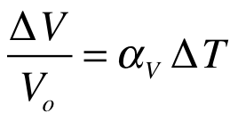
∆L is change in length ∆V is change in volume
Lo is initial length Vo is initial volume
alpha is linear thermal expansion coeff. alpha is volumetric thermal expansion coeff.
∆T is change in temperature ∆T is change in temperature

11. Fourier’s Law of Cooling
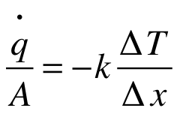

q/A is heat flux (units W/m^2)
k is thermal conductivity (units W/m•K)
∆T is temperature change across sample
∆x is thickness of sample

On tests, Professor De Guire often asks questions where you must rank different materials according to a specific material property (specific heat, thermal expansion coefficient, thermal conductivity). Below I have listed typical values for some important material properties. Write these on your notecard.

12. Typical values for thermal expansion coefficients

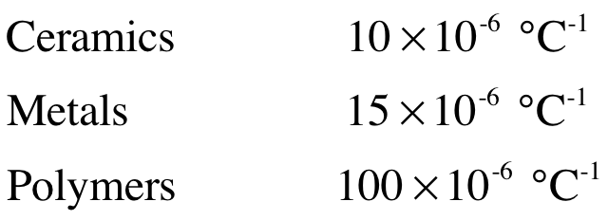

13. Typical values for thermal conductivity
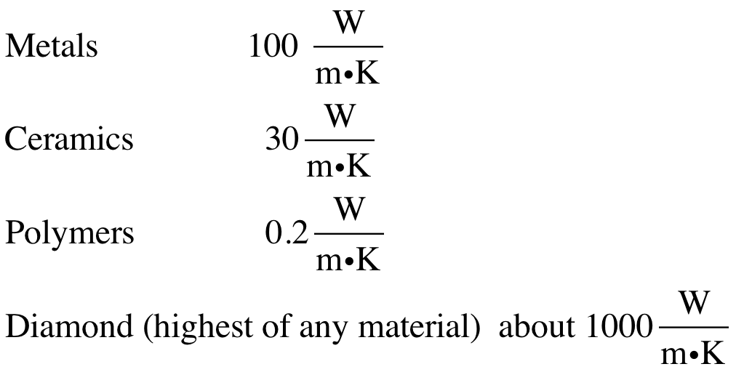

14. Typical values for specific heat

