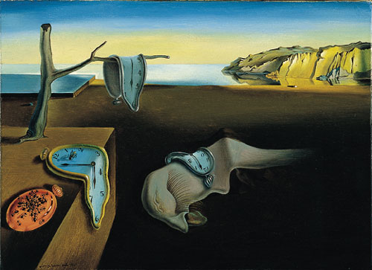
Persistence of Memory, Salvador Dalí

