Project Two: Due Date -- Monday Nov. 10, 2008 before 8 am.

You are expected to submit your programs to your TAs while in lab. If you choose not to be in lab and are accessing Karel elsewhere, the program must be received by the TAs no later than 8 am on Monday 11/10/08.

Problem Statement:
Karel has been assigned the task of planting a single beeper on each and every intersection throughout a maze. However, there are no beepers left at the origin. Instead the beepers Karel needs will be found at the center of the maze. Unfortunately, over the years some beepers have gotten planted in random places and in odd numbers throughout the maze. Karel must ensure that there is exactly one beeper on each intersection in the maze. Karel knows that there will never be more than 3 beepers accidently planted anywhere in the maze. When the beeper planting is completed Karel must come home to the origin and face North.

Clearly the problem statement is not sufficiently detailed to be able to write a program. Writing the program is your job. Below is a picture of the World Karel will be working with for this Project. You can try downloading it from the Web, or simply recreate it on your own in the lab (recreating it is easier).

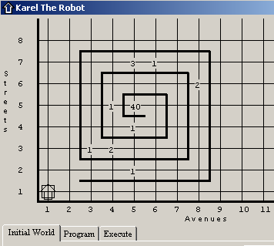

The purpose of this project is to demonstrate that you understand all of the programming concepts taught this semester. In particular, this project requires the use of IF statements and WHILE statements. Textbook chapters 1-5 are important to this project.

Project One is worth 100 points.

1. Your program must solve the problem stated above. It must work properly. It must compile correctly and end with a turnoff command and not an error message. (40 points)
2. You must use two (2) WHILE statements in this program. One While statement is needed to get to the center of the maze and the other is used to get out of the maze. (15 points each = 30 points)
3. You must use at least two (2) IF statements in this program. (10 points each = 20 points)
4. Karel must be at the origin and face NORTH at the end. (5 points)
5. You must email your TA with your BigMaze.yourlastname.kp Your email message needs to contain your First and Last Name and your Person number as well as your program as an attachment. (5 points)

Simply printing off your program and handing it to your TA is not sufficient. You will get NO (ZERO) credit for turning in a printed copy. The TAs will Execute your code to see if it works.

