Project One: Final Due Date -- Monday March 23rd no later than 12 noon.

Attendance is required in Lab for all Karel the Robot work. You are expected to submit your programs to your TAs while in lab. If you choose not to be in lab and have access to Karel, the program must be received by the TAs no later than 12 noon on Monday March 23rd. Submission MUST be done via email.

For this project, your program file should be named:

RowBeeperProgram.yourlastname

In place of the word yourlastname put your last name. So my file would be named RowBeeperProgram.kershner Karel’s programming language will add the extension .kp
My file would then have the name: RowBeeperProgram.kershner.kp

Problem Statement:
Karel starts at the Origin (Street 1, Avenue1) facing North. There are four boxes in a row. Karel must pick up four beepers at the origin and put them in his beeper bag. Karel needs to deposit one beeper into each box. Karel then goes home to the origin and face north. Karel’s beeper bag is empty at the start.

Clearly the problem statement is not sufficiently detailed to be able to write a program directly. Writing the program is your job. Below is a picture of the World Karel will be working with for this Project. You should recreate it on your own in the lab or on your own machine. Instructions fro downloading the World are listed under Project One in the Projects page on the website.

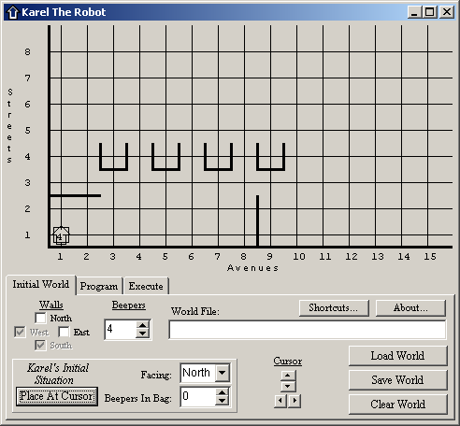

The purpose of this project is to demonstrate that you understand the concept of creating new instructions for Karel to follow AND that you can effectively use the iterate command. Defining new instructions is carefully explained in Chapter-3 in your textbook and the iterate command is explained on pages 93 and 94 in the text. These will also be explained in class.

Project One is worth 100 points.
1. Your program must solve the problem stated above. It must work properly. It must compile correctly and end with a turnoff command and not an error message. (50 points)
2. You must create the new instruction turnright for Karel to use. (5 points)
3. You must use the iterate command to pick up the four beepers located at the origin that Karel will need to plant in the boxes. (5 points)
4. You must create two additional new instruction commands that help Karel solve the problem. (20 points)

These newly created instructions must be useful to Karel and you must use each one more than once in your program. Ideally, your instructions should be useful enough to be used with all four boxes.

5. You must use at least one additional iterate command to simplify your program. ((5 points)
6. You must return Karel to the start (origin) where Karel begins its travels. (5 points)
7. Karel must end up facing North. (5 points)
8. You must email your TA with your RowBeeperProgram.yourlastname.kp
You are emailing the PROGRAM with the ending .kp NOT the World. The TAs have access to the World and do not need another copy.
Your email message needs to contain your First and Last Name and your Person number as well as your program as an attachment. If you do not know how to do this your TA can show you how to accomplish this task in lab. (5 points)

Simply printing off your program and handing it to your TA is not sufficient. You will get NO (ZERO) credit for turning in a printed copy. The TAs will Execute your code to see if it works.

