R on Jupyter. Feb 6, 2017.
Overview: This was a lab prepared for learning R on RStudio. Let’s try it on Jupyter.
Pre-requisites: Jupyter and R kernel on Jupyter Installed.
- Now that you have Jupyter and R kernel installed, we will go through a list of several basic commands you will find useful.
- Variables are assigned using the “varname <- value” syntax, as follows:
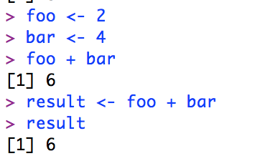
Notice how when you declare these variables, the “Environment” section becomes populated.
- You can also create vectors. Vectors (or lists) are created using the “combine” function, called c(). Note that the indices start at 1, not 0:
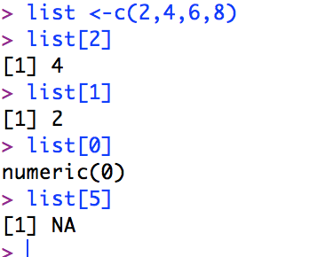
- R also supports basic arithmetic and Boolean expressions:
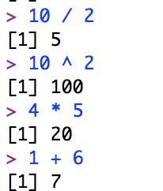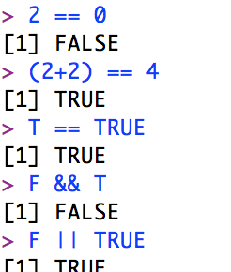
- We can combine all of the above functionality. Try creating a vector called “vect” with several numbers. Multilply the vector by 2 (i.e. vect * 2) and press Enter. Take a look at the result.
- In addition to performing operations on each element of a vector like we did before, we can call functions on them. Try calling sqrt(vect) and observe the result.
- We can also give names to the elements of a vector like so:
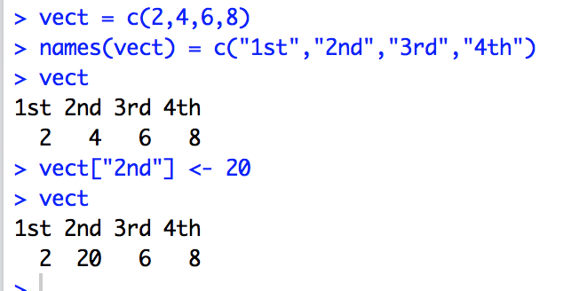
You can also use control statements such as if.. else, and for loop; print for debugging, etc.
- Let us examine R’s graphic capability: go to the console window and type
demo(graphics)
and observe the visualization possible with R graphics.

- Basic plots: Line graphs, histograms, box plots: Save the images generated as pictures(.png)
Problem 1: Define two synthetic vectors of data representing sales over 12 months for 2 items. Compare the two using lines graphs. (Discussion; Run the code multiple time and see randomness of the second set of data..)
sales1<-c(12,14,16,29,30,45,19,20,16, 19, 34, 20)
sales2<-rpois(12,34) # random numbers, Poisson distribution, mean at 34, 12 numbers
par(bg="cornsilk")

plot(sales1, col="blue", type="o", ylim=c(0,100), xlab="Month", ylab="Sales" )
title(main="Sales by Month")

lines(sales2, type="o", pch=22, lty=2, col="red")
grid(nx=NA, ny=NULL)
legend("topright", inset=.05, c("Sales1","Sales2"), fill=c("blue","red"), horiz=TRUE)

Problem 2: The sales data is available in a table in a text file. Read it in and draw a side-by-side histogram to compare the performance. (Discussion)

sales<-read.table(file.choose(), header=T)
sales # to verify that data has been read
barplot(as.matrix(sales), main="Sales Data", ylab= "Total",beside=T, col=rainbow(5))

Problem 3: Use boxplot to compare the two sales data. (Discussion: How will you interpret the graph visualization?)

fn<-boxplot(sales,col=c("orange","green"))$stats

text(1.45, fn[3,2], paste("Median =", fn[3,2]), adj=0, cex=.7)
text(0.45, fn[3,1],paste("Median =", fn[3,1]), adj=0, cex=.7)
grid(nx=NA, ny=NULL)

- Importing data into R studio: from csv, (ODBC relational data source: later), from the web documents. Data available from sources such as fueleconmy.gov, data.gov, yahoo.finance etc.
http://www.fueleconomy.gov
http://www.fda.gov/aboutfda/transparency/opengovernment/default.htm
Historical prices at yahoo finance: http://finance.yahoo.com/q/hp?s=AAPL+Historical+Prices

Problem 4: Download csv data from the web and analyze using the methods above. Download the historical prices for any two or more sticks of your choice and compare. We will do it for Apple (AAPL) and Facebook (FB) for one year.
- We will download the csv file by specifying the URL string in the file reader in R.
- Alternatively you can download using the data import tab of the right top quadrant of R Studio.
fb1<-read.csv("http://real-chart.finance.yahoo.com/table.csv?s=FB&d=10&e=5&f=2014&g=d&a=11&b=12&c=2013&ignore=.csv")
par(bg="limegreen")
plot(aapl1$Adj.Close, col="blue", type="o", ylim=c(0,100), xlab="Days", ylab="Price" )
lines(fb1$Adj.Close, type="o", pch=22, lty=2, col="red")
legend("topright", inset=.05, c("Apple","Facebook"), fill=c("blue","red"), horiz=TRUE)
Just study the distribution of the adjusted close of the stock price of Apple.
hist(aapl1$Adj.Close, col=rainbow(8))

(Analysis)

- Problem 5: Data sets available with R: R community has created a lot of data for others to use. Examine the data sets already available with R. data(), attach(),detach(), head(), summary()
data()
Observe the data sets available for explorations.
attach(mpg)
head(mpg)
summary(mpg)
#after analysis remove the data from the memory
detach(mpg)

Also explore newer data sets in
library (help=datasets)
library(datasets)
head(uspop)
plot(uspop)
Also look at this github site: http://vincentarelbundock.github.io/Rdatasets/datasets.html

- Problem 6: Accessing external APIs: eg. Google map lat-long API: “map” command.
The idea here is to plot the results of analysis on a map: geographical or otherwise. List a collection of cities you have visited and plot it on a map.
library("ggmap")
library("maptools")
library(maps)
visited <- c("SFO", "Chennai", "London", "Melbourne", "Johannesbury, SA")
ll.visited <- geocode(visited)
visit.x <- ll.visited$lon
visit.y <- ll.visited$lat
map("world", fill=TRUE, col="white", bg="lightblue", ylim=c(-60, 90), mar=c(0,0,0,0))
points(visit.x,visit.y, col="red", pch=36)

Here is another example using the map of The United States.

library("ggmap")
library("maptools")
library(maps)
visited <- c("SFO", "New York", "Buffalo", "Dallas, TX")
ll.visited <- geocode(visited)
visit.x <- ll.visited$lon
visit.y <- ll.visited$lat
map("state", fill=TRUE, col=rainbow(50), bg="lightblue", mar=c(0,0,0,0))
points(visit.x,visit.y, col="yellow", pch=36)

We can get very high resolution maps, different types of maps, geographical maps, historical maps, and plot on them any information you like. Check this document:
Maps package: http://statacumen.com/teach/SC1/SC1_16_Maps.pdf

- Problem 7: we will conclude the “base” graphics capabilities of R package with a very old but popular data set available in R: mtcars (motor trends car package). Attach and explore mtcars. Draw scatter plots of the dependent variables (i) 5 variables (ii) 4 variables.
Repeat the plot with some other rich data set from R package.
splom(mtcars[c(1,3,4,5,6)], main="MTCARS Data")
splom(mtcars[c(1,3,4,6)], main="MTCARS Data")
splom(mtcars[c(1,3,4,6)], col=rainbow(),main="MTCARS Data")

Another data set: “rock”
splom(rock[c(1,2,3,4)], main="ROCK Data")

- Problem 8: Working with ggplot2 package (), loading a package, installing package. Object-oriented and incremental additions (extensibility) are special features of this package. We can layer the commands to a base plot.
Later we will work on a problem from Chapter 2 of the Data Sciences book.

