This equation sheet is meant to be my recommendation for information to put on your notecard. This is NOT a list of everything you should know.

**1. First law of thermodynamics**

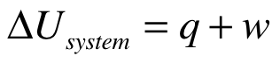

if q is positive, heat is going into system

if w is positive, work is being done on the system

**2. Calorimetry**

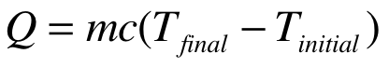 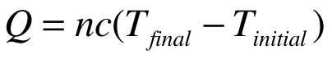

Explanation of variables (typical units are given in parentheses)

Q is heat gained or lost (J) Q is heat gained or lost (J)

m is mass of sample (g) n is number of moles (mol)

c is specific heat capacity (J/g •K) c is molar heat capacity (J/mol•K)

**3. For heat exchange at constant pressure**

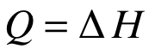

**4. Enthalpy of reaction**

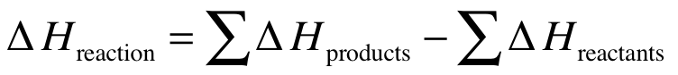

Remember to use the appropriate stoichiometric coefficients when you calculate ∆H.

You could write identical equations for ∆S and ∆G.

**5. Heat capacity at constant pressure vs. heat capacity at constant volume**

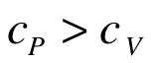

this assumes that we are considering cp and cv for the same material

**6. Gibbs free energy (∆G)**

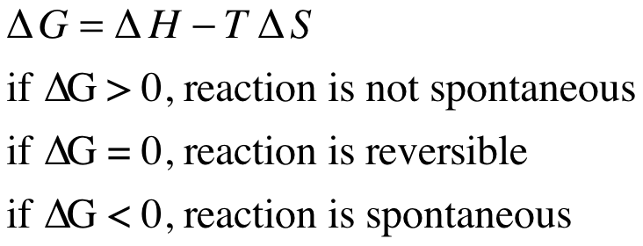

**7. Entropy (∆S)**

to calculate ∆S for a temperature change

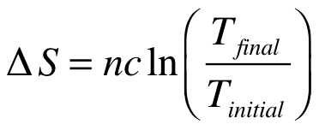

n is number of moles

c is molar heat capacity

-If we are at a constant pressure, then use cp

-If we are at a constant volume, then use cv

to calculate ∆S for a volume change (at a constant temperature)

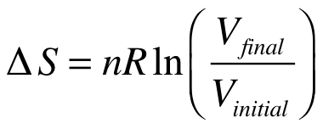

n is number of moles

R is gas constant

to calculate ∆S for a phase change

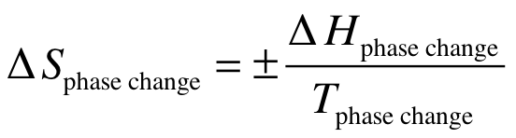

Use the plus sign if you are going from solid to liquid (melting) or liquid to gas (evaporation). Use the minus sign if you are going from gas to liquid (condensation) or liquid to solid (freezing).

**8. Equilibrium constant (K)**

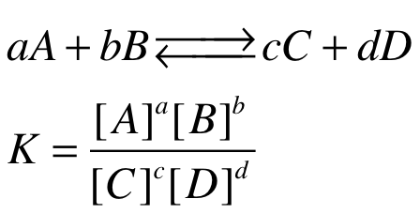

**9. Relating the equilibrium constant to Gibbs free energy**

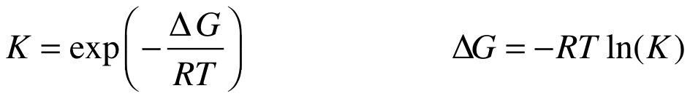

These expressions are equivalent. One is solved for K and the other is solved for ∆G.

**10. Thermal expansion**

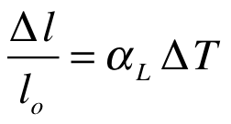 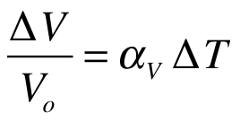

∆L is change in length ∆V is change in volume

Lo is initial length Vo is initial volume

alpha is linear thermal expansion coeff. alpha is volumetric thermal expansion coeff.

∆T is change in temperature ∆T is change in temperature

**11. Fourier’s Law of Cooling**

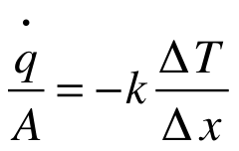

q/A is heat flux (units W/m^2)

k is thermal conductivity (units W/m•K)

∆T is temperature change across sample

∆x is thickness of sample

On tests, Professor De Guire often asks questions where you must rank different materials according to a specific material property (specific heat, thermal expansion coefficient, thermal conductivity). Below I have listed typical values for some important material properties. Write these on your notecard.

**12. Typical values for thermal expansion coefficients**

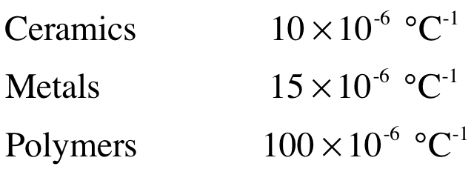

**13. Typical values for thermal conductivity**

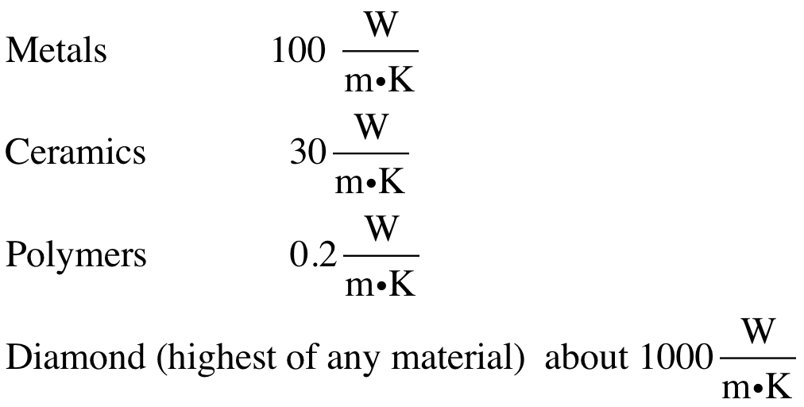

**14. Typical values for specific heat**

