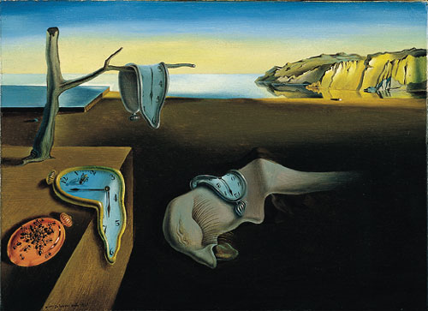

Persistence of Memory, Salvador Dalí