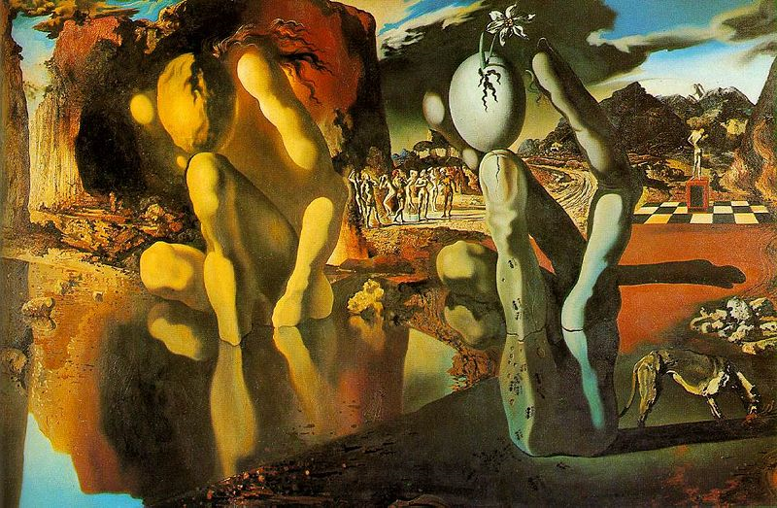

Metamorphosis of Narcissus, Salvador Dalí

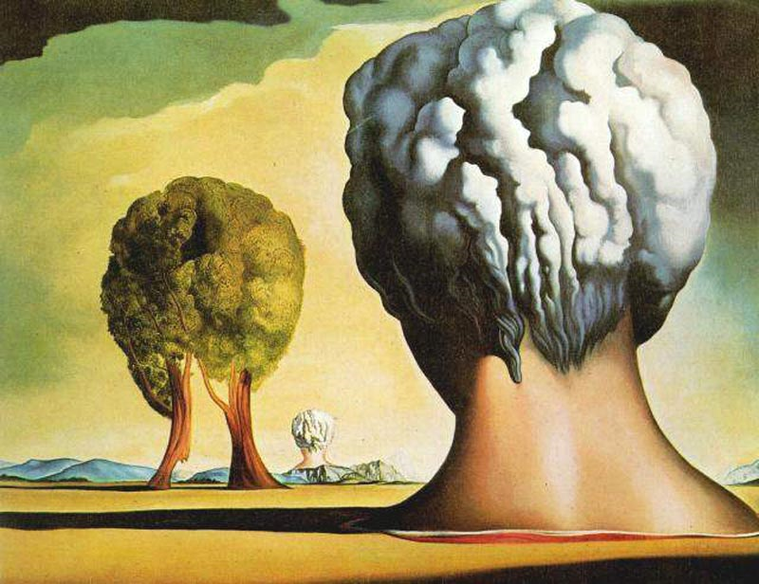

Three Sphinxes of Bikini, Salvador Dalí