Importing the Botanical App database from a staff member’s updated spreadsheet - a legacy process from the early days, but it provides some insight into the database’s structure.

1. Detach the current BotanicalApp databse.
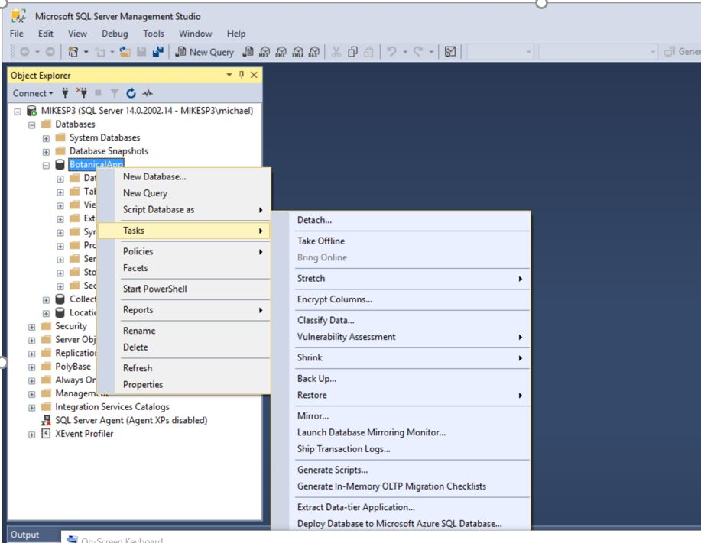
2. Archive the detached files somewhere for safe keeping:
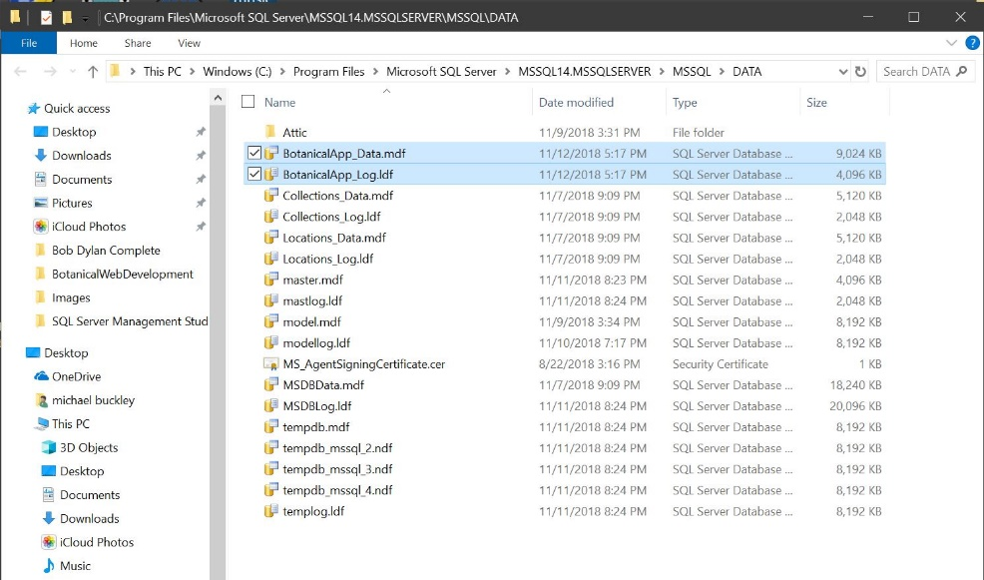
3. Start the 64 bit Import Wizard
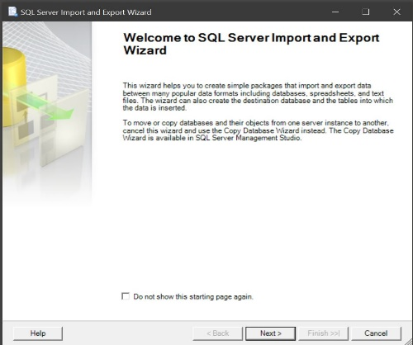
4. Choose Excel as the source, specify the XSLX file:
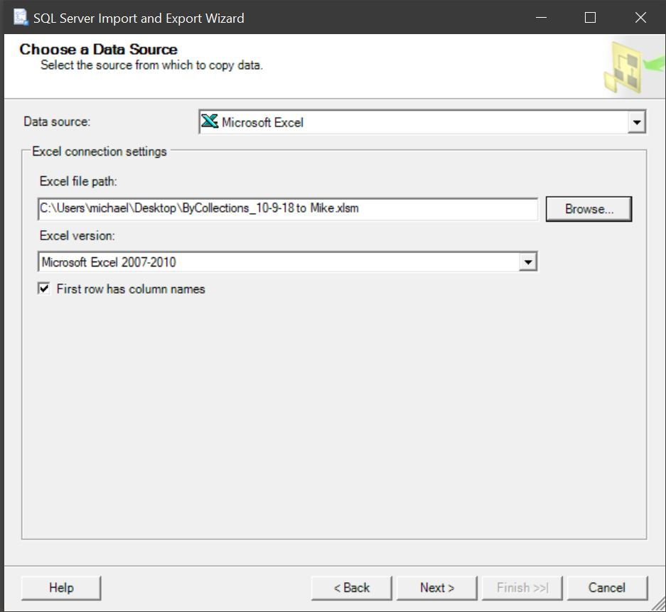
5. Choose SQL Server Native Client 11.0 as the destination, and select NEW database. The new database must be named BotanicalApp. Specify the correct server for your SQL Server installation.
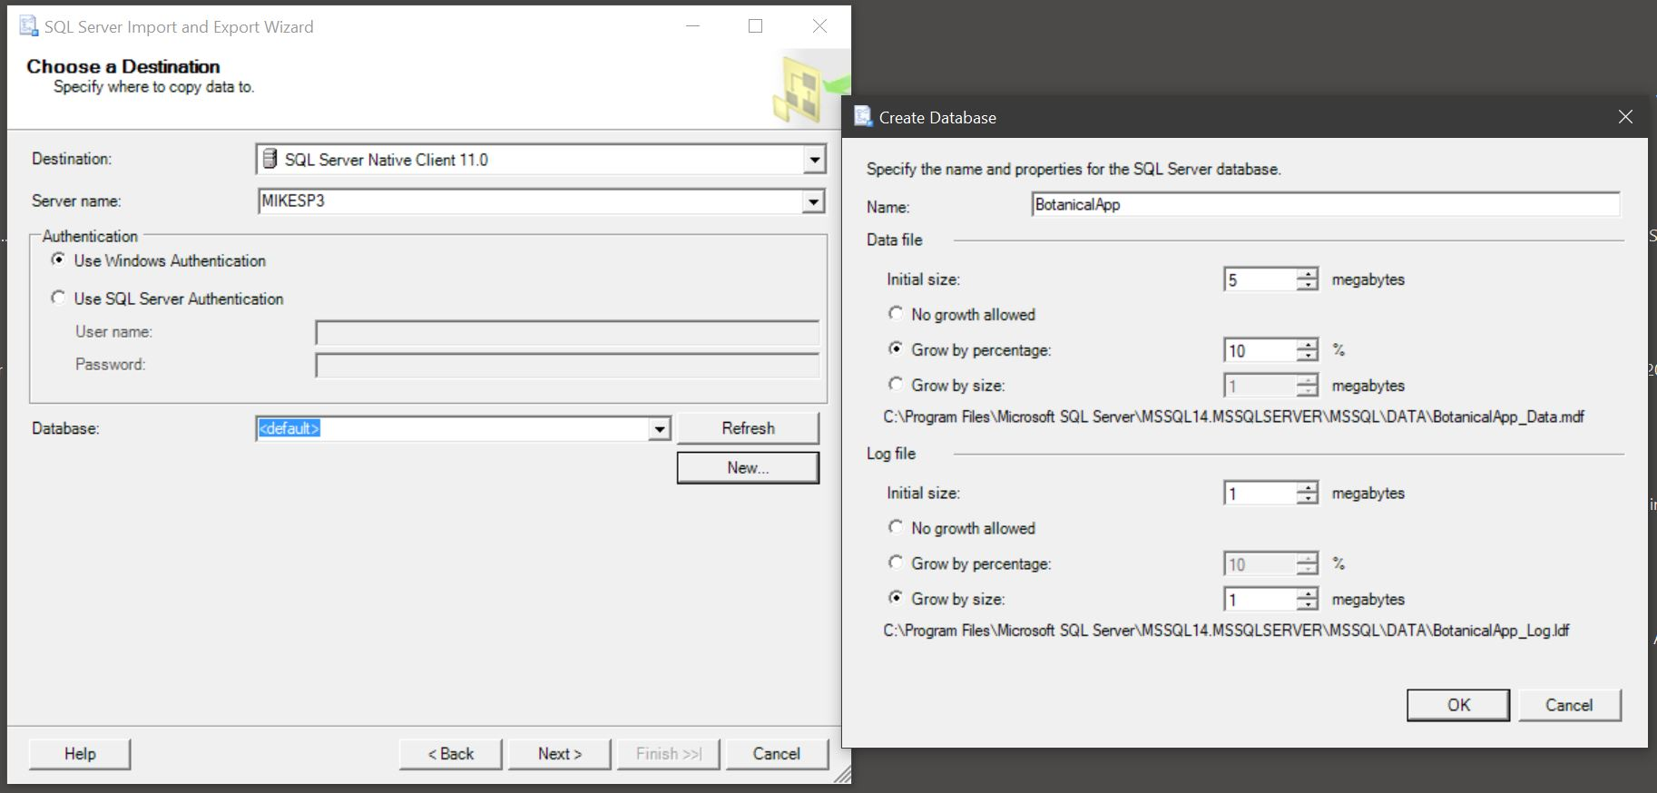
6. Create the PlantData table in the new database:
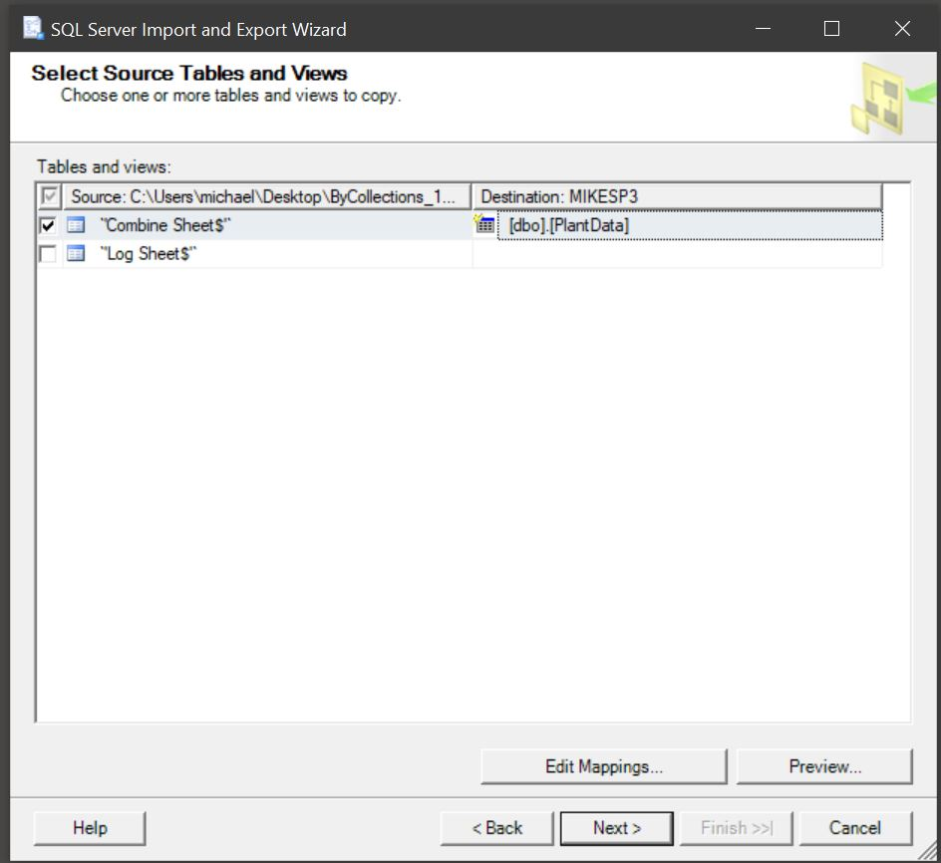
7. Finish the database creation. Note: if all the following items are not “successful”, there is a mismatched field or perhaps a Description field that is too long.

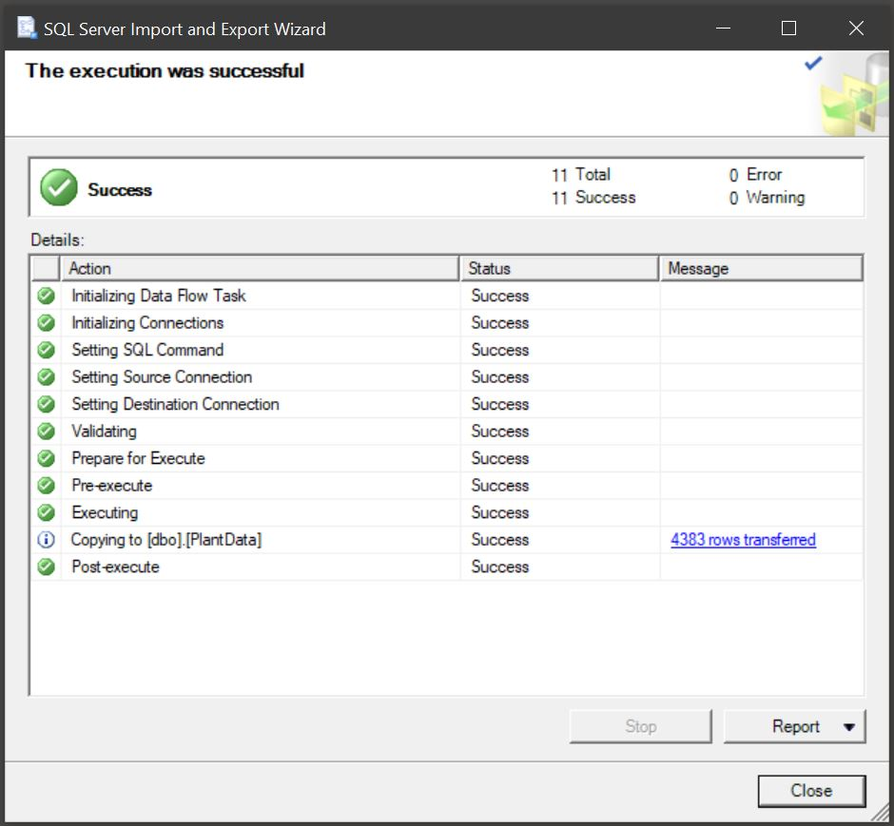

8. Open the database in SQL Server Management Studio, and inspect the PlantData table. Note there is no “ID” column (PlantID is not the datbase ID).

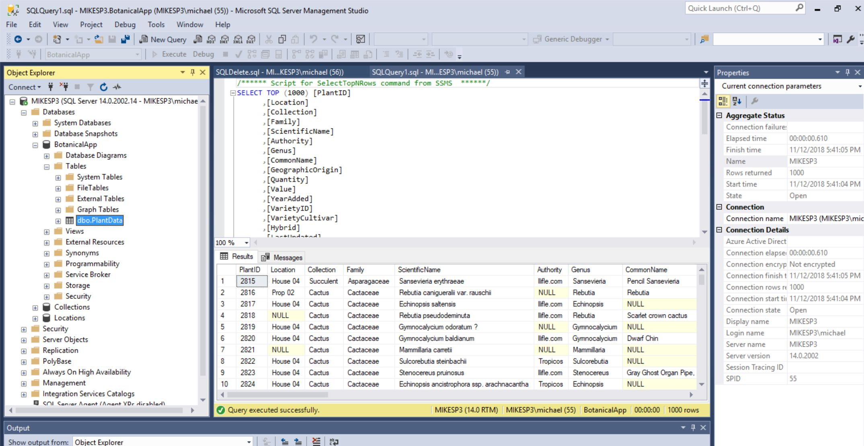
9. Run a DELETE SQL Queery to get rid of empty rows (the Wizard creates them for some reason):
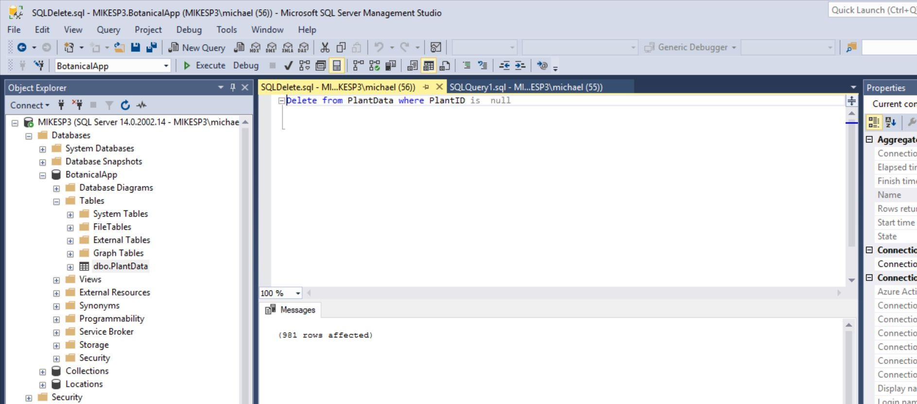

10. Create the all-important ID column, under the Table/Design. It must be the first column, and have Identity Specification / Is Identity set TRUE. The increment should be 1. SET IT AS THE PRIMARY KEY by right-clicking on it.
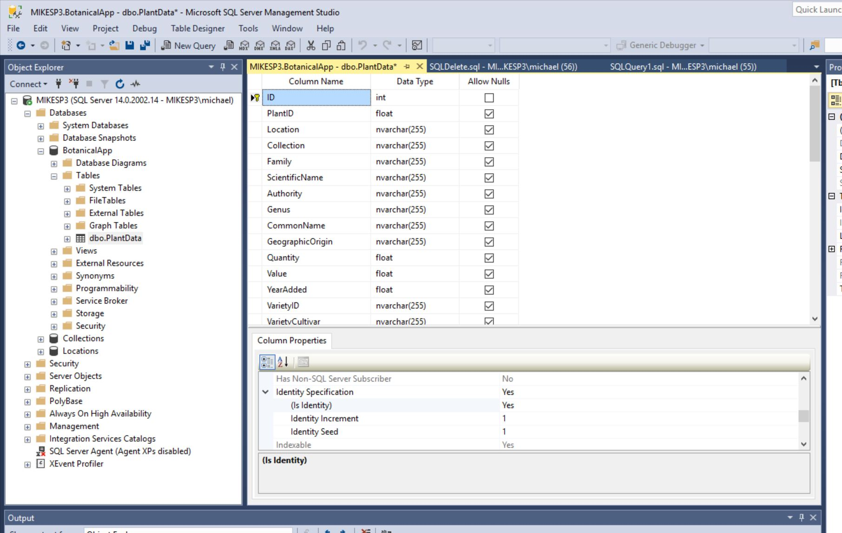
11. Save it. If it doesn’t save, UNcheck the box in Tools/Options that says “prevent saving changes that require table re-creation”.
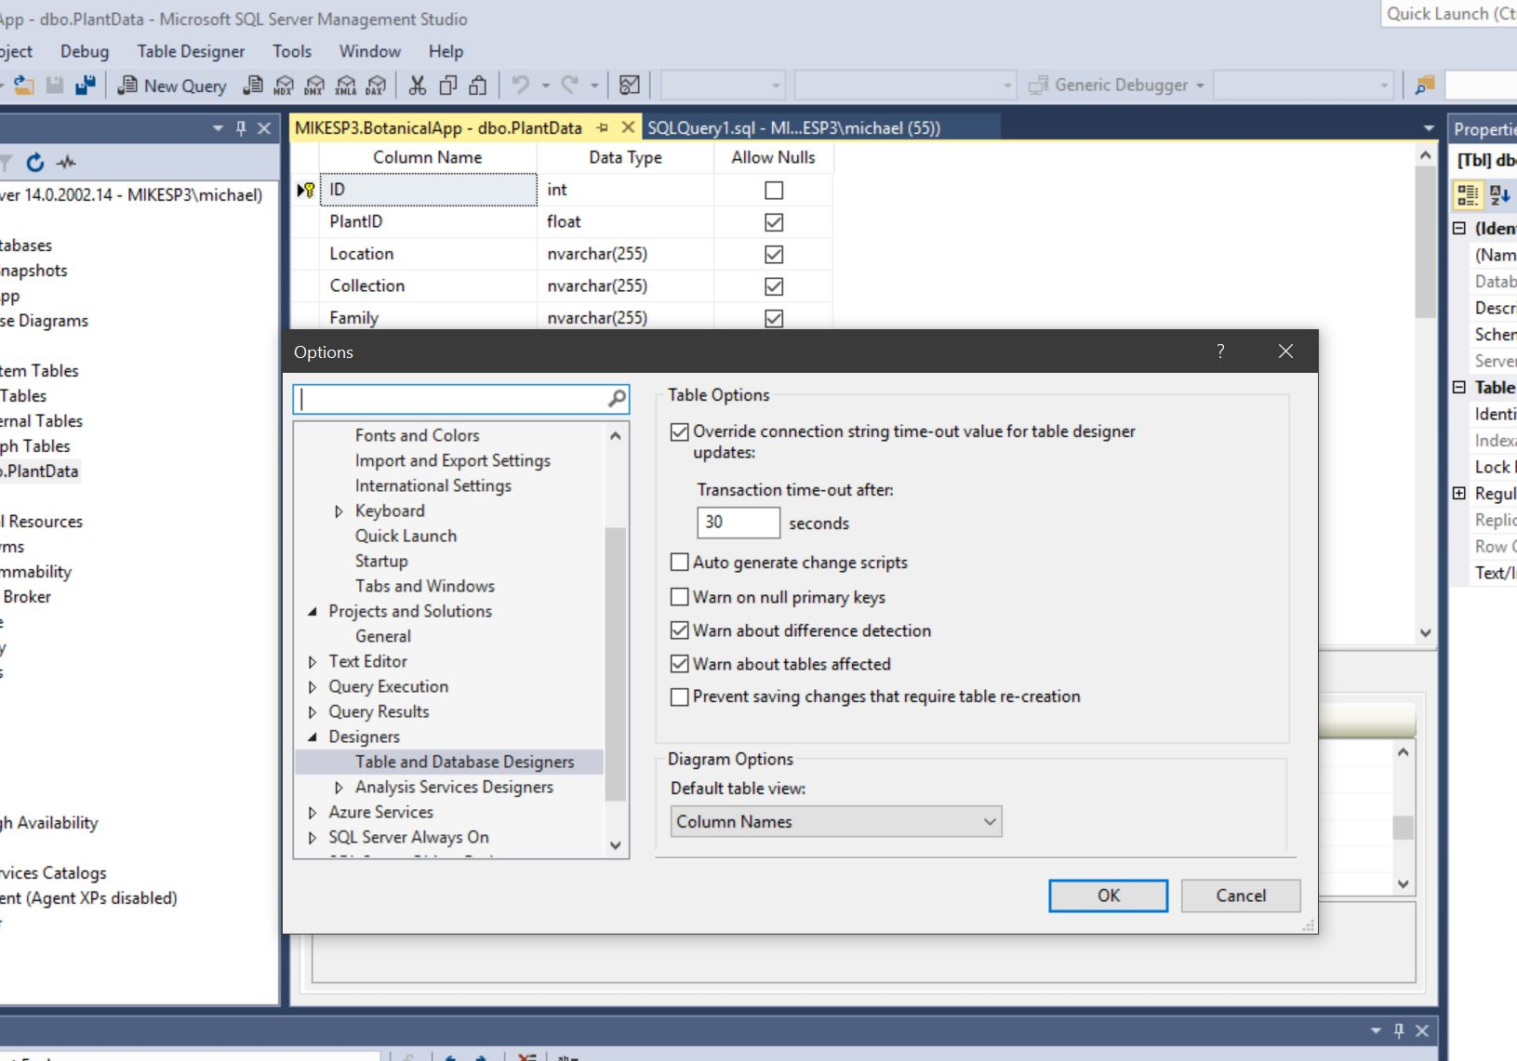

12. Inspect the finished PlantData table:
