Installing the Botanical Gardens Database
1. Make sure that Visual Studio, SQL Server, and Management Studio are installed and operational. Note the name of your Server (it will be the same as your Computer Name under Control Panel/System) and will appear when Management Studio is started:
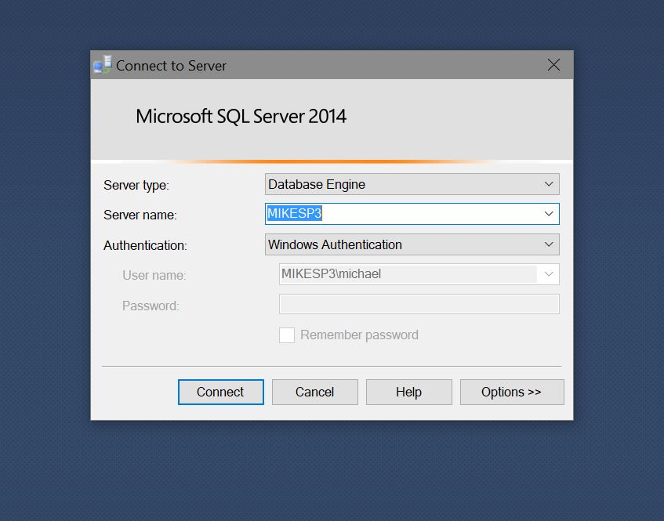
2. Locate the SQL Server Data folder. Use Windows File Explorer. It will be something like:
C:\Program Files\Microsoft SQL Server\MSSQL12.MSSQLSERVER\MSSQL\DATA

Here is the location of database files on my computer. Find the same folder on your computer….
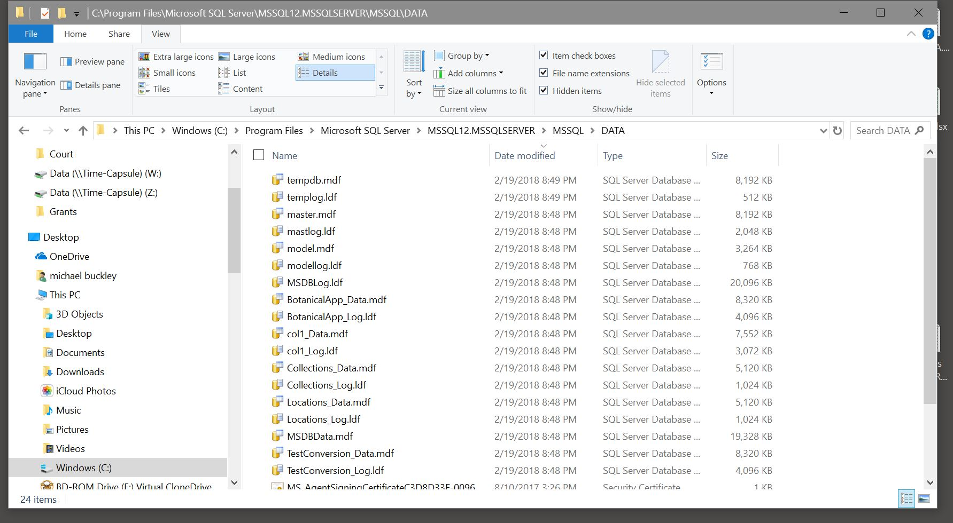
Another way to locate the database files is to:
1. Open SQL Management Studio
2. Expand the Databases folder on the left
3. Expand System Databases folder
4. Right-click on “master” database, and select “Properties”
5. In the Properties window, choose “Files”
6. The “Path” column indicates the location of your database files
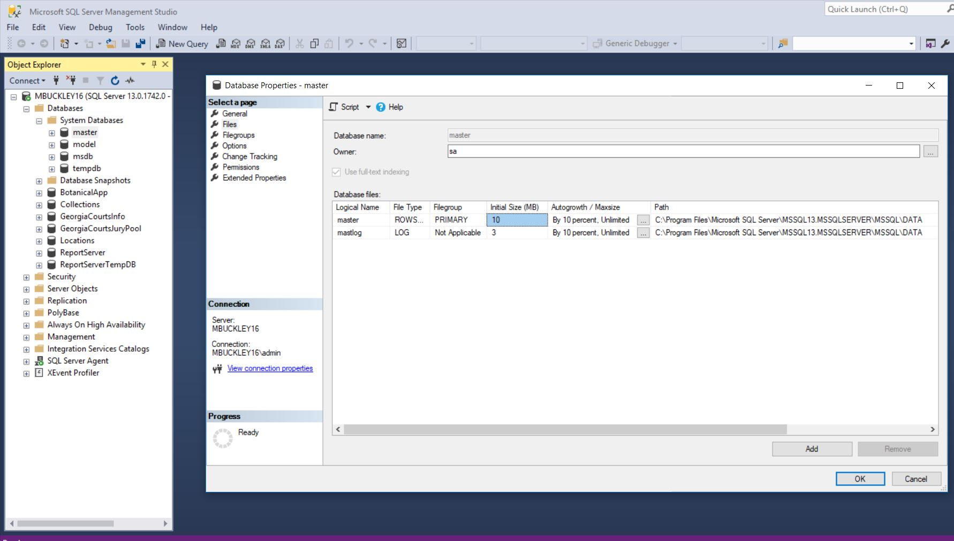
3. Copy the following files to that directory:
BotanicalApp_Data.mdb
BotanicalApp_Log.ldb
Locations_Data.mdb
Locations_Log.ldb
Collections_Data.mdb
Collections_Log.ldb

4. In ManagementStudio, right-click on “Databases” in the Object Exploerer and select “Attach”. This is where you add databases to your SQL Server:
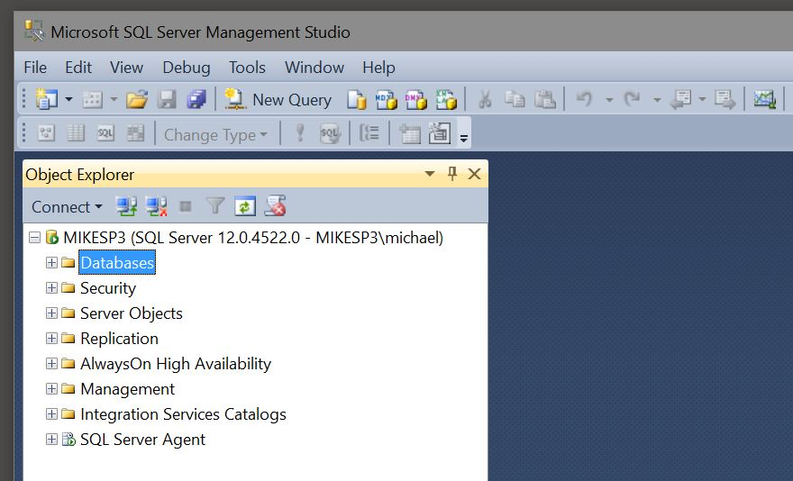

5. The Attach menu comes up and select the “Add” button:
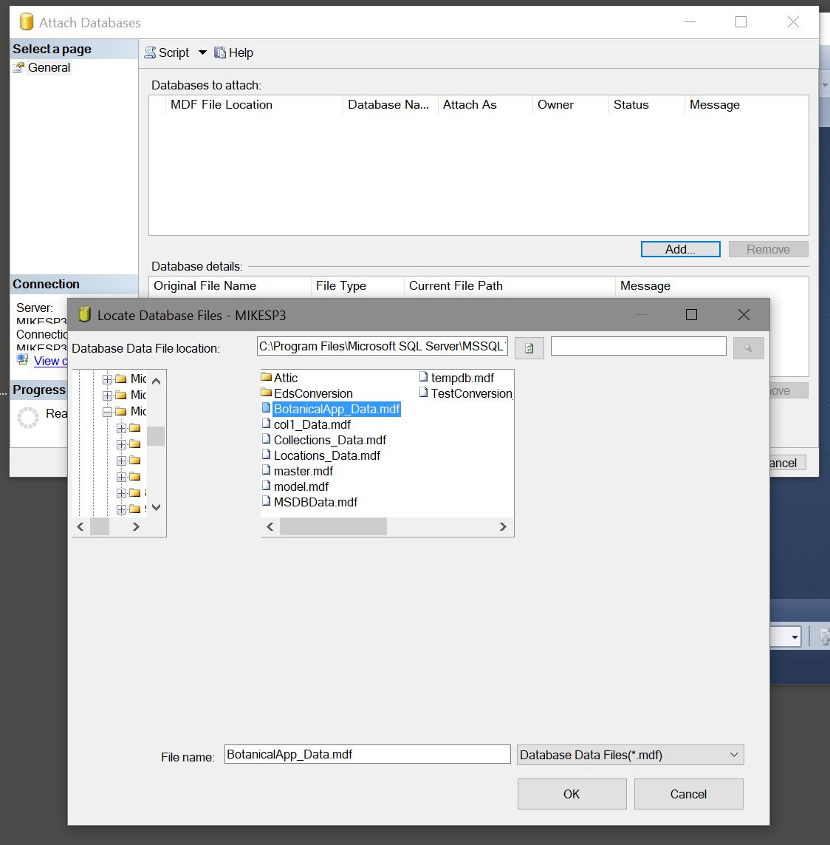
6. Select the BotanicalApp_Data file, then OK. The following menu should appear:
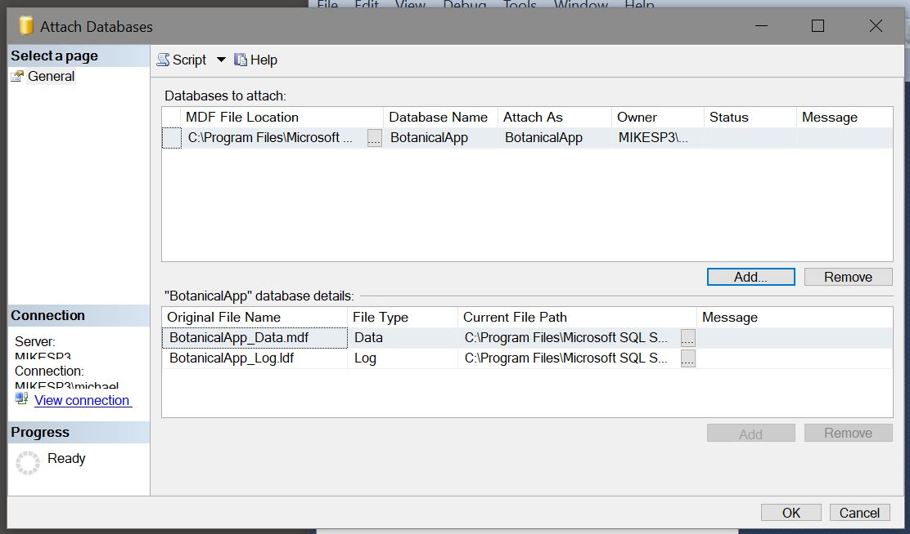
Select OK.
7. Repeat for the Collections_Data file, and the Locations_Data file.

8. After Attaching the three databases, you should be able to locate Tables for all three. This is the PlantData table for the BotanicalApp Database:
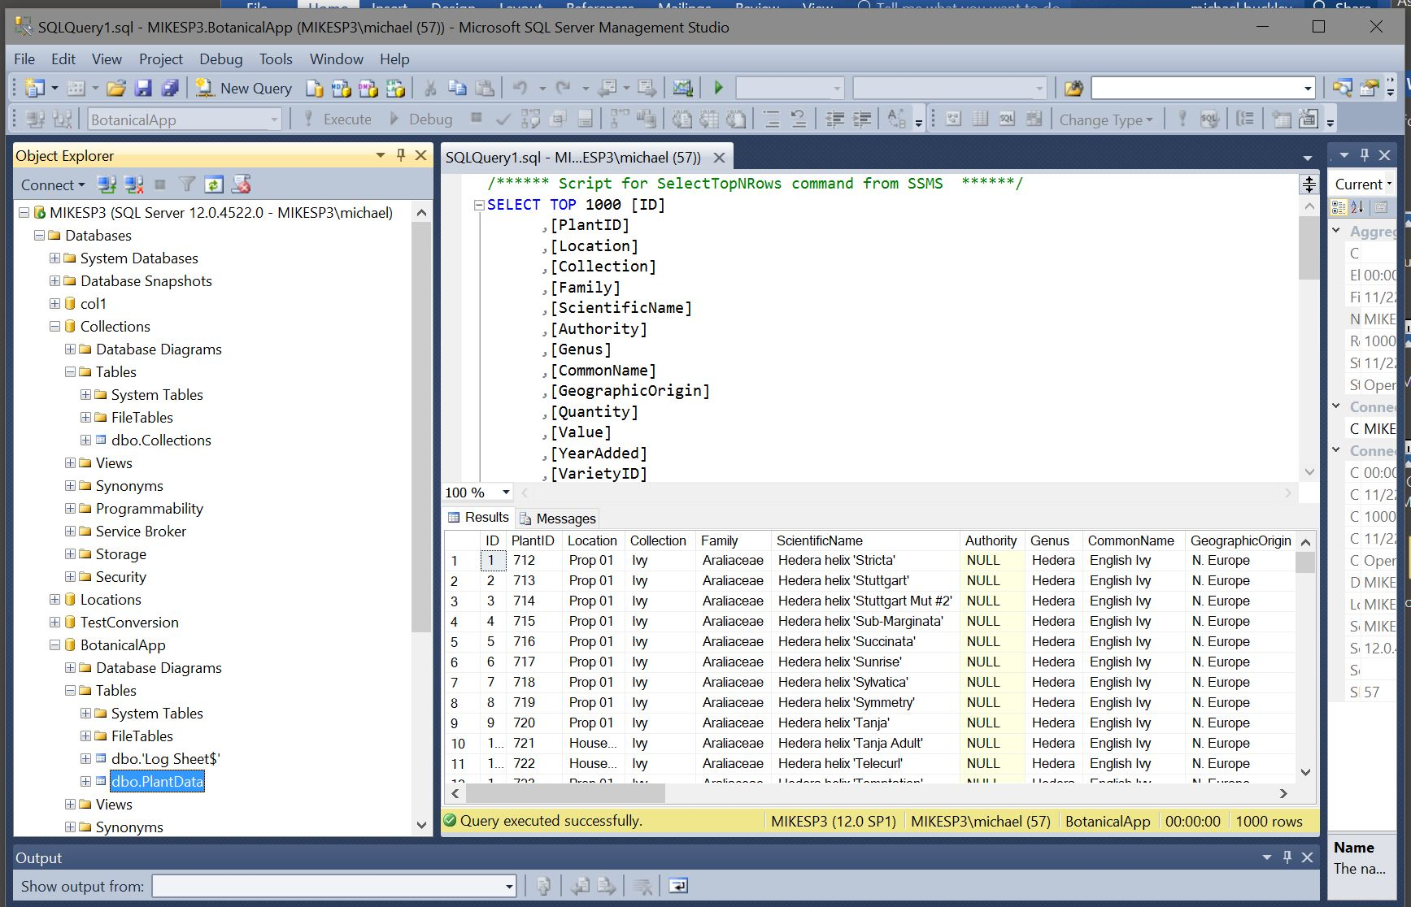
To get that display, right click on PlantData, and “Select Top 1000 rows”.
9. The Collections database has a Collections table, and the Locations database has a Locations table.

