Rentable

Technical Design Document

1. Tech Stack
Backend:
Firebase ( https://firebase.google.com/ )
Firebase is a comprehensive app development platform that provides backend functionalities like authentication, analytics, cloud storage, databases, hosting, messaging and crash reporting.

Frontend:
Android XML (https://developer.android.com/guide/topics/ui )
Android provides a variety of pre-built UI components such as structured layout objects and UI controls that allow building the graphical user interface for the app. Android also provides other UI modules for special interfaces such as dialogs, notifications, and menus.

Firebase Realtime Database:
(https://firebase.google.com/docs/database)
The Firebase Realtime Database is a cloud-hosted database. Data is stored as JSON and synchronized in real-time to every connected client with the NoSQL cloud database and remains available when the app goes offline.

Pricing:

The pricing for firebase follows “pay as you go” strategy. The real time data base for about 1 GB is free and for every additional 5GB it costs 5$. The download cost or for the transfer cost of data if free until 10GB and costs 5$ for every additional 5GB. Where for the storage it costs free until 1GB and charges 0.13$ for every additional 5GB, whereas the transfer rates are free up to 30GB and charges 0.6$/5GB. The hosting of the data costs 0.03$/1GB and the transfer rates for these costs 0.75$/5GB.

Version Control:
Github (https://github.com/)
Github is a web-based distributed version-control system for tracking changes in source code during software development. It is designed for coordinating work among programmers, but it can be used to track changes in any set of files. Its goals include speed, data integrity, and support for distributed, non-linear workflows.

Tools:
Android Studio (https://developer.android.com/):
Android Studio is the official integrated development environment (IDE) for Google's Android operating system, built on JetBrains' IntelliJ IDEA software and designed specifically for Android development.

2. Accounts and Infrastructure
Firebase Spark account provides authentication, database, storage which will be used for developing the mobile application.

The application will be tested in the local environment by simulating few users and their data. It will be tested end to end as per the Test plan after Development phase before deploying it in the Google play store as a beta version.

2.1 Development
Development and Testing of the mobile application are done on individual team member local machines and integrated using Git Version Controlling software.

Each user will have a separate account to sign up and login to. The account details will be stored in the Database and can be monitored by the admin if required.

2.2 Production

Data Sources, Models, Timing

1.1 Data Sources
The database is built upon user-entered data which consists of user profile and information about the various categories of goods that are being rented.

1.2 Data Models and Structure
The Firebase Realtime Database is a cloud-hosted database. Data is stored as JSON and synchronized in real-time to every connected client with the NoSQL cloud database and remains available when the app goes offline.

{
"username" :
“password” :
"Address" :
"Name" :
"Mobile" :
"Products" : [ {

"Product_Id" :
"Product_Name" :
"Price" :
"Posted_Date" :
"image_url" :
}]
}

As Firebase’s real-time database is NoSQL Database, we can have different entity attributes based on our needs.

1.3 Timing
Application and Database logs are captured by the firebase which are used for timely performance monitoring. Data will be stored permanently in the database. The user’s product information – images, name of the product, description, security deposit and the amount charged per day for the item all will be considered as data. User Data and his rentable/rented product data will be archived if the user deletes his account.

System Architecture Diagram

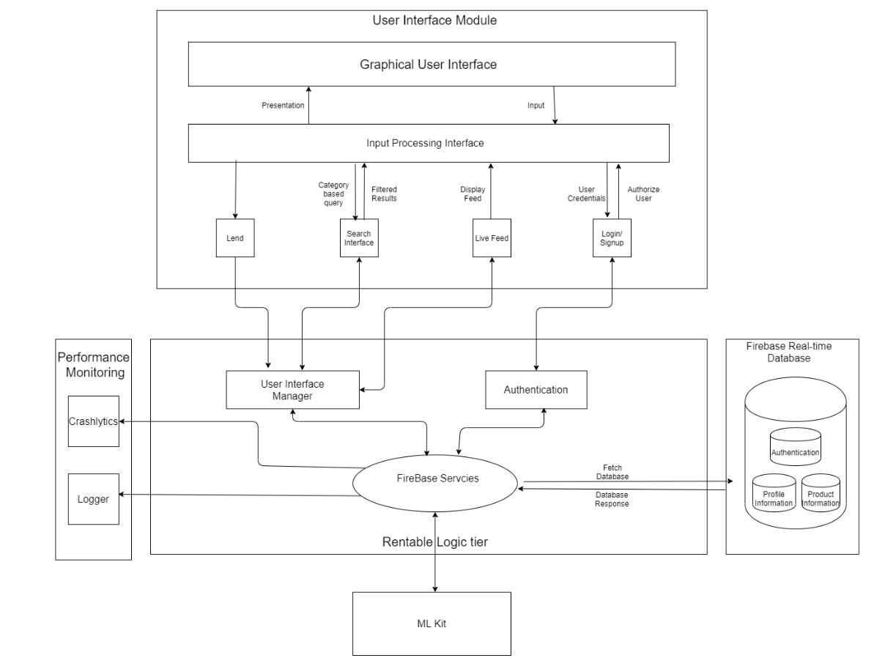

User Interface Module:

This is the Graphical User Interface for the Mobile Application.

Lend: This Interface allows the user to capture the rentable product using camera and provide details related to the product to be lended.

Search Interface: This Interface provides the User to filter the feed results using multiple filters available..

Live Feed: This Interface displays a list of products available based on the filters applied by the user.

Log In / Sign Up: This Interface provides the user to provide his credentials to access the services of the Rentable Mobile Application.

Rentable Logic Tier:

This module handles requests / responses from the User Interface Module.

User Interface Manager: This manages the interaction between Graphical User Interface and multiple services provided by Firebase for proper functioning of the application based on user inputs and actions.

Authentication: This module acts as a gateway between Login/Sign Up interface and Firebase Authentication Service.

Firebase Services: This module is the core which handles functioning of the Mobile application that interacts with various modules in the system like Firebase Real-time Database, ML-Kit, Logger, Crashlytics etc.

Performance Monitoring:

This module captures the application activity of the user for future use.

Logger: This module logs all the activities in a timely manner and any unusual activity of the application.

Crashlytics: This module has information when application is crashed due to unexpected events at run-time and reports are generated to debug further and fix any bugs.

Firebase Real-time Database:

This module is NoSQL database provided by Firebase for data storage.

Authentication: This module stores the authentication information of the users in the form of JSON which is used for authorization.

Profile Information: This module consists of user profile information in the form of JSON which is used by the business to uniquely identify users and their activities on the application.

Product Information: This module consists of rentable products information that need to be displayed on the feed based on User preferences.

Deployment Methodology

Rentable Mobile Application will be deployed in the Google Play Store.

