Christopher Fritz^{1*}, Ramalingam Sridhar¹
¹Univeristy at Buffalo, Buffalo NY 14261
*Corresponding author: email: cvfritz@buffalo.edu; phone: 716-796-8073

Fine-grained minimal overhead value-based core power gating on GPGPU

Abstract— Modern computing systems use parallelism to increase performance. Through the addition of large amounts of extra hardware, power consumption in computational hardware becomes an increasingly important research area. Graphics processing units are designed with thousands of cores to achieve immense performance and throughput breakthroughs. However, within the thousands of computational units on a GPU, it has been shown that much of the time, all of the bit data paths are not needed. Due to the immense amount of parallel hardware, leakage power consumption becomes a major concern. We use a simple low-level enhancement to perform power gating at the ALU level to reduce leakage power consumption by up to 45% for modern GPGPU applications. Slices of arithmetic circuits can be shut off if they are not needed based on the input bits for a nearly zero overhead penalty. Our method can also be used alongside the numerous other methods which perform power gating in a similar fashion but at a higher level, for compounded savings.

Index Terms— Leakage power, GPGPU, fine grained power gating,

INTRODUCTION
F
ine grained power gating is a commonly used method in which individual components (down to the gate level) within a module are disabled when not in use. This is in contrast to coarse-grained methods, which typically disable entire modules, or even entire cores. Fine grained power gating architectures typically involve simple additional circuitry to derive power gating criteria without adding much overhead, whereas coarse-grained methods might use more complicated schemes such as statistics monitoring to determine when an entire module has been idle for long enough to warrant being disabled. [1, 2]

Power gating methods generally involve the use of sleep transistors, called either header switches or footer switches, as depicted in Fig. 1. A control signal is produced, and when it is asserted, the module or block will be disabled by isolating it from either the power or ground rail. The sleep transistor is disabled, such that no current flows into the circuit. In this way, leakage power consumption can be substantially reduced. When a sleep transistor is used on the power supply rail, it is called a header switch, and forms a virtual VDD. On the ground side, the sleep transistor is called a footer switch, forming a virtual ground. [1]. Typically, either a header switch or footer switch is used but not both, to minimize the area overhead penalty. [2]

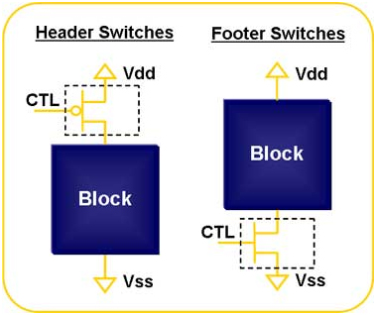
Many prior works present methods for power gating, in terms of efficiently deriving the gating criteria with minimal area and performance penalty, and trading off the granularity of the method versus the complexity of the additional control logic. Arora, Jayasena, and Schulte presented a method by which different statistical prediction methods can be used in parallel to compute power gating criteria, and the best performing method can be chosen in a tournament style based on which algorithm is best performing for a specific application. [15] This type of power gating must be done in a coarse-grained way, and is used to disable entire processor cores. The additional logic in this case is too complex to implement for targeting savings at a lower level than this.
Figure 1: Two types of power gating

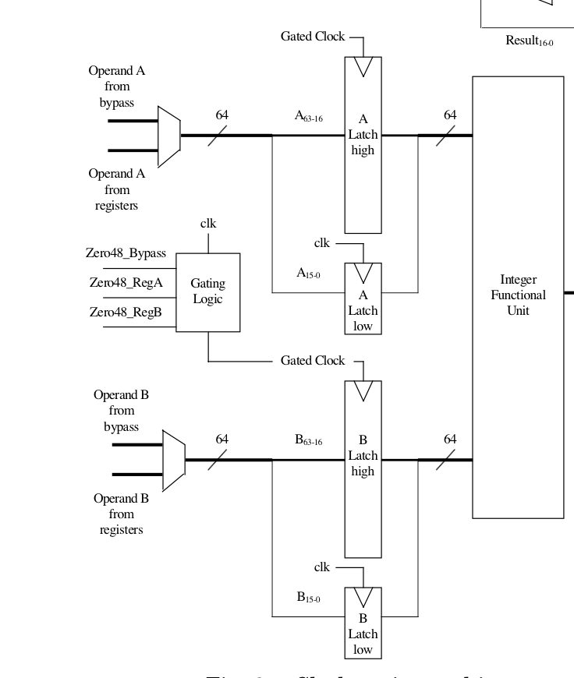
Other methods have been presented which reduce power consumption at a more fine-grained level, using the value inputs to determine gating conditions. Brooks and Martonosi presented an effective method to reduce dynamic power consumption by multiplexing N zeros in place of input bits if all of them are zero. The corresponding arithmetic components are then clock gated so that they consume no dynamic power. As the outputs of the corresponding arithmetic units will be zero anyway, the modules can still compute the correct answer. The authors demonstrated up to 70% of dynamic power reduction using SPEC benchmarks. [5] While this is technically not power gating but clock gating, it demonstrates a principle of using the input values to arithmetic components themselves to reduce unneeded power consumption for parts of arithmetic circuit that would return zero values anyway.

Modern compute-intensive applications increasingly rely on graphics processing unit architectures. As a GPU has thousands of cores which can operate in parallel, computation can be carried out with enormous throughput. Using a GPU to perform general purpose computation is a scheme named General purpose computing on GPU, or GPGPU. [3] Due to the large number of parallel components, power gating methods have potential to have a large impact in this platform.
Figure 2: Brooks and Martonosi's Value based clock gating method

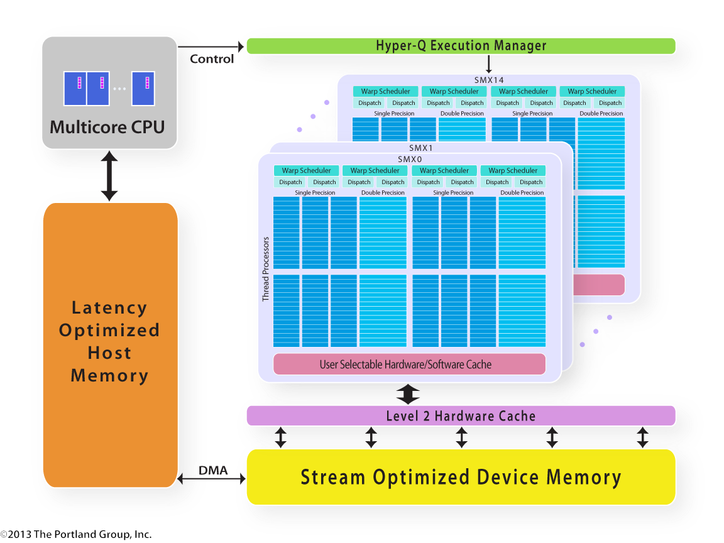
The nVidia Fermi Architecture exposes the software programming model for the GPU itself. In general, a GPU in a GPGPU application executes a sequence of kernels. The parallel processing units inside the GPU itself are called Streaming Multiprocessors (SM) which execute multiple threads in parallel and contain a small software-managed cache. One important concept is that of the warp, which is a collection of (usually 32) threads that all execute on one SM at the same time. The SMs have integer and floating point data paths for each thread in the warp. The programming model used is called Single Input, Multiple Thread (SIMT), in which every thread in the warp executes the same instruction at the same time (similar to the SIMD model). [4]
Figure 3: nVidia Fermi GPGPU Hardware Architecture

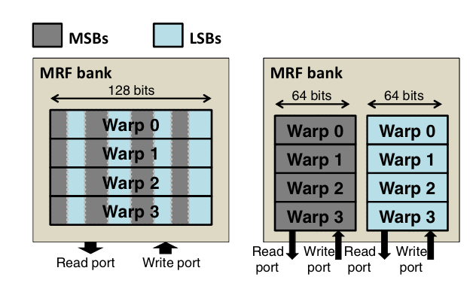
GPGPU energy consumption is a major current research area. [13, 15, 16] As modern GPUs can have on the order of 2800 cores [4], the opportunities for power savings are enormous. At AMD, Schulte, Kim, and Gilani presented a method for reducing the dynamic power consumed during a GPGPU application by creating separate data paths based on the input values. They showed that for GPU benchmarks, the input operands and results presented to a 32 bit computational core could be represented by only 16 bits much of the time. The actual percentage of the operands with this property depends on the benchmark, but on average, around 60% of integer instructions can be represented by only 16 bits. In this way, and reminiscent of Brooks and Martonosi’s work, the authors presented an architecture in which a separate data path would be used if the most significant 16 bits were simply sign extended bits. Using simulation tools, they demonstrated savings of 25% in dynamic power consumption on GPGPU architectures. [6]
Figure 4: Schulte's (AMD) separated register files
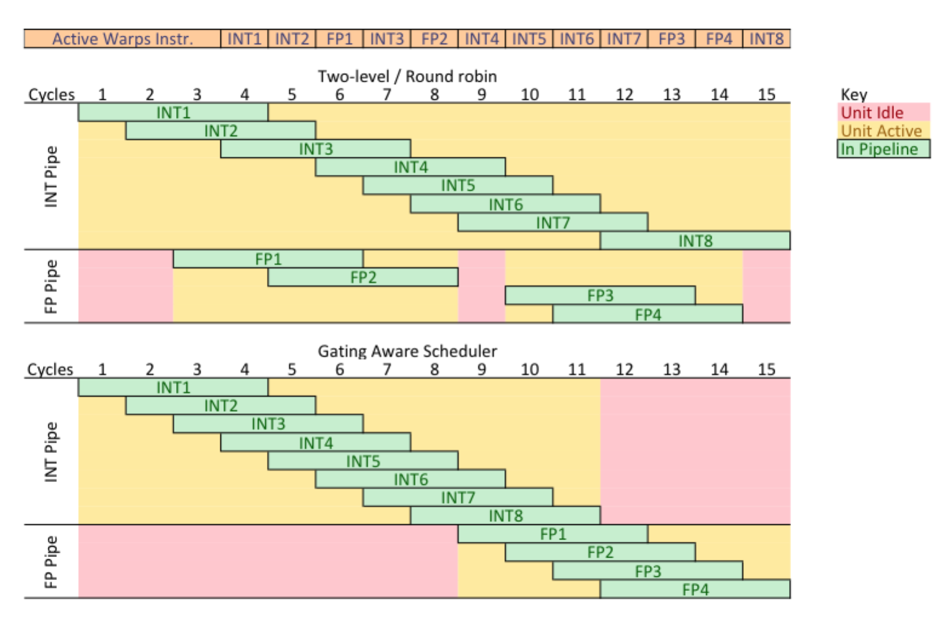
Other methods have been presented to save power on GPGPU architectures. Wong, Abdel-Majeed, and Annavaram proposed an architecture known as “Warped Gates” in which integer and floating point instructions, which are typically interspersed by the warp scheduler, are instead grouped and executed altogether. This allows the floating-point unit to be disabled when during the integer cycles, and vice-versa, making the warp scheduler “Gating Aware”. The authors demonstrated a 31% reduction in leakage power when using this method coupled with their “Blackout power gating” method which does not allow gated units to awaken until enough time has passed for the power savings to break even, at a minimal performance penalty.
Figure 5: Wong, Abdel-Majeed, and Annavaram's Warped Gates scheudling

Other recent research also concerns similar methods. Researchers at AMD published “Understanding idle behavior and power gating mechanisms in the context of modern benchmarks on CPU-GPU integrated systems” at the 2015 IEEE Symposium on High Performance Computer Architecture (Indrani Paul, Manish Arora, et al.) [16] This work outlines many methods of performing power gating using modern benchmarks, largely concerning cache fine-grained leakage power reduction. Similar to the Prediction for Power Gating work by the same group, in this work they propose a new prediction algorithm using Linear Prediction methods making heavy use of previous idle trends.

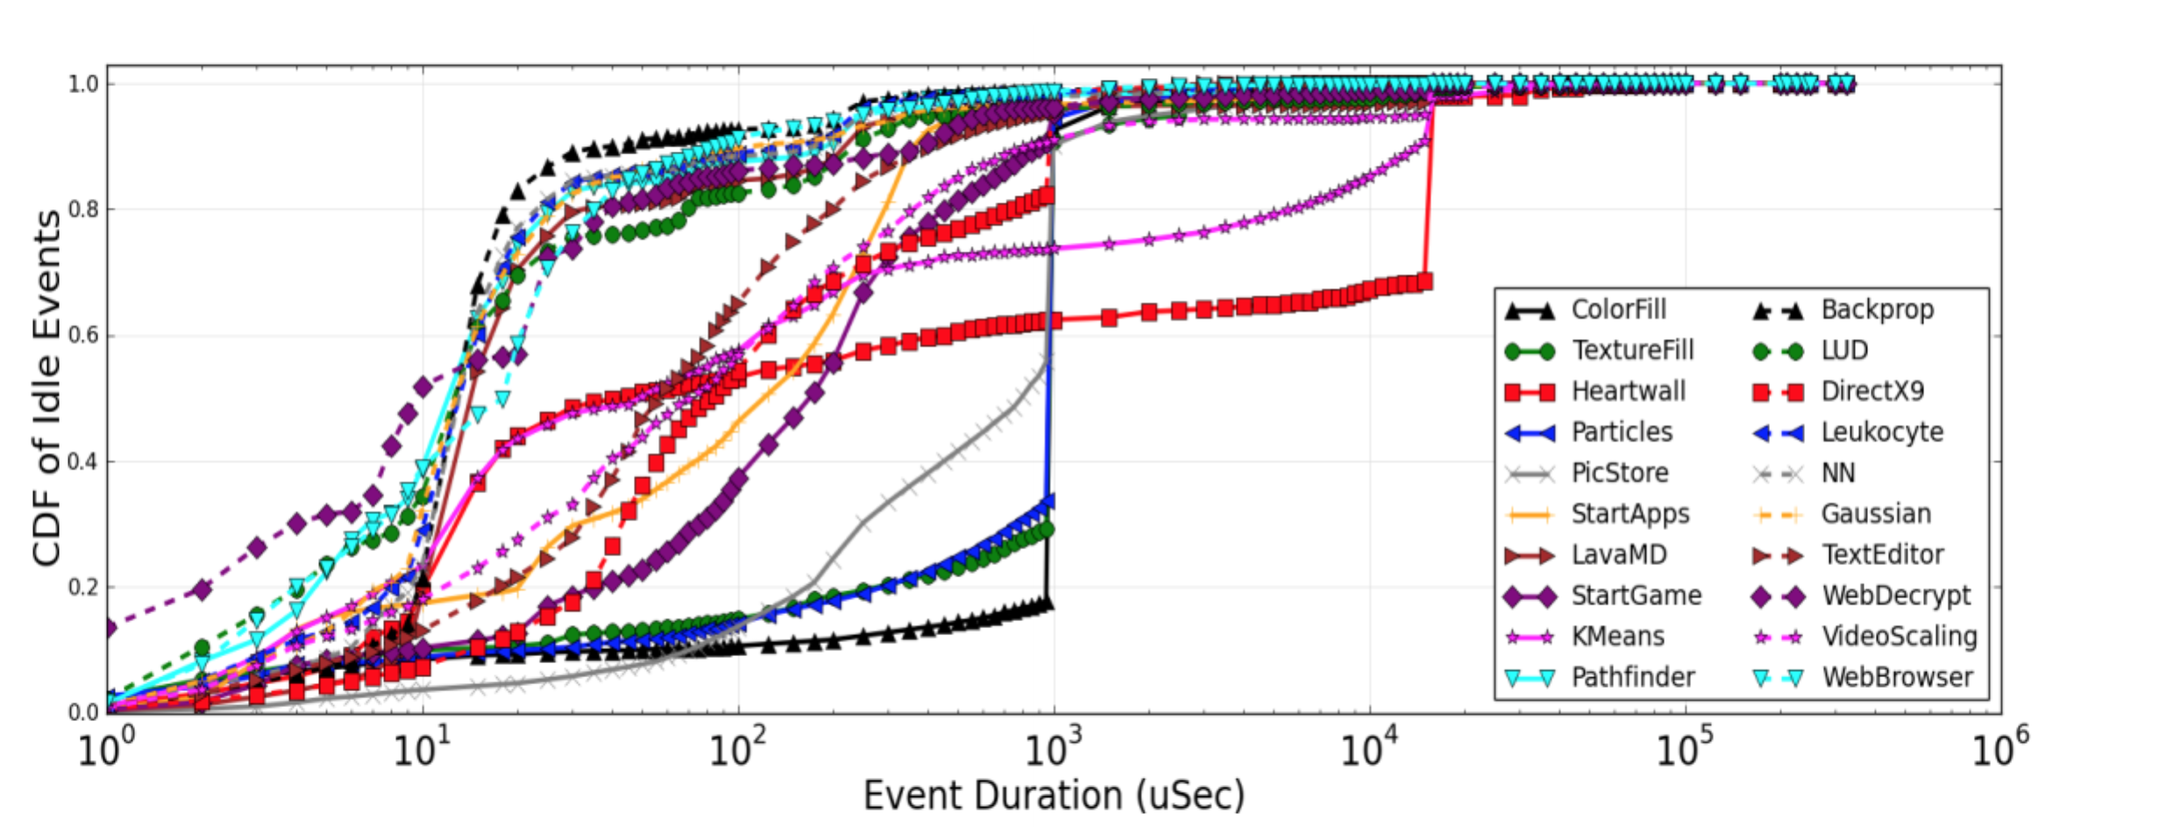
Figure 6: Arora, Paul's CDF of idle event duration

Arithmetic Circuit Fine-Grained Value Based Power Gating
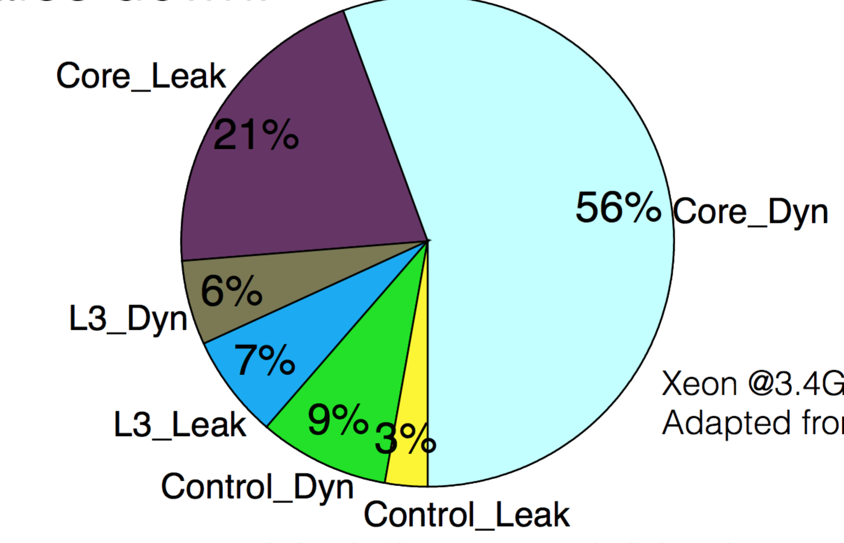
Our method generally targets leakage power consumption in the integer ALU and FPU computation units in the computational cores of the GPU when running GPGPU applications. Leakage power consumption accounts for at least 30% of total power consumption on modern systems, and much more on some systems. The core leakage power has been measured at 27% of the leakage power and is expected to increase. [12]

We consider a simple arithmetic circuit, such as a 32-bit Kogge-Stone adder, commonly used in the integer ALU in many computational systems. We seek to disable the transistors comprising the adder circuit by taking advantage of the same property as in [5] and [6], that the output of the adder circuit will be zero when the corresponding pair of input bits is zero. Where the other applications bypassed these components using separate data paths, we will operate at a lower level by simply disabling the entire slice of the arithmetic circuit and strapping the output to zero nearly eliminate leakage power from those components for the entire computational cycle. We present a method to perform the zero detection and power gating adding no extra power overhead and nearly no performance penalty. At the lowest level in which we are operating, it is essential that we do not add power overhead in the form of complex prediction units because this will quickly cancel the benefit of the methods we are using.
Figure 7: Power consumption breakdown of modern computational core

Minimal overhead zero-detection module
Any carry look-ahead adder first computes the propagate and generate bits using a half-adder module consisting of an exclusive OR gate and an AND gate.

$$P_{i}=A_{i}⊕B_{i}$$ | (1)
$$G_{i}=A_{i}B_{i}$$ | (2)

We also want to compute the OR of the two input bits but do so without adding any power overhead
$$Z_{i}=A_{i}+B_{i}$$ | (3)

We note that the XOR gate must compute the negation of at least one of the input bits. The simplest XOR gate must compute or have access to at least one of the bit complements. With this in mind, we can simply compute the $Z_{i}$ values using Complementary Pass-transistor Logic. We use this style because it adds a minimal overhead in terms of gate usage – the OR function can be computed using just two additional transistors. More importantly, however, is that by using pass-transistor logic, we add no gates with a conduction path from VDD to ground. In this way, the modified half adder module should consume virtually no additional power, but still produce the desired output. Fig. 8 depicts a schematic view of the modified half adder circuit. Note that we have used just one of several XOR gate schematic styles; the one chosen is simplest but still must compute the complement of one of the inputs.
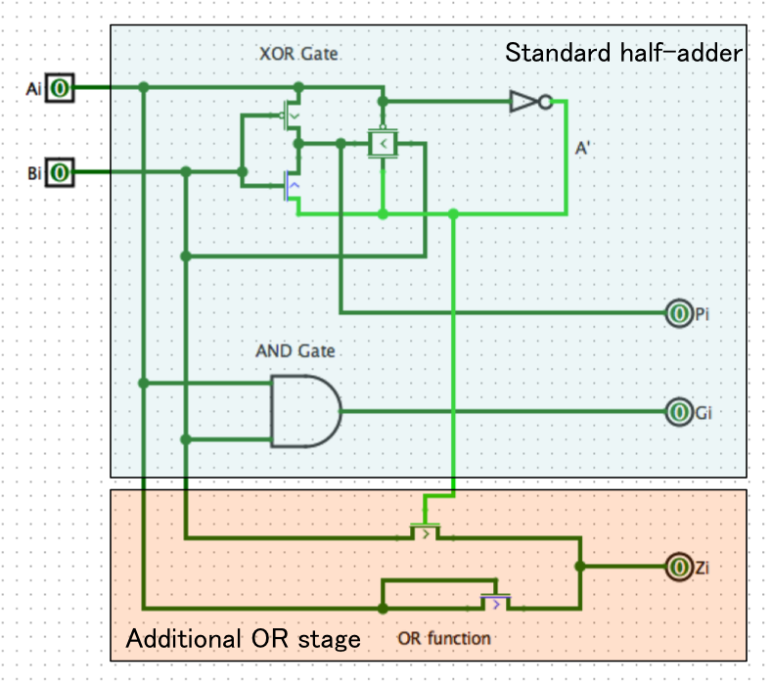
We simulate the half adder schematic using Cadence. The simulation reveals no additional power consumed by adding the additional stage. In this way, we can derive power gating conditions with no power overhead, and only two additional transistors.

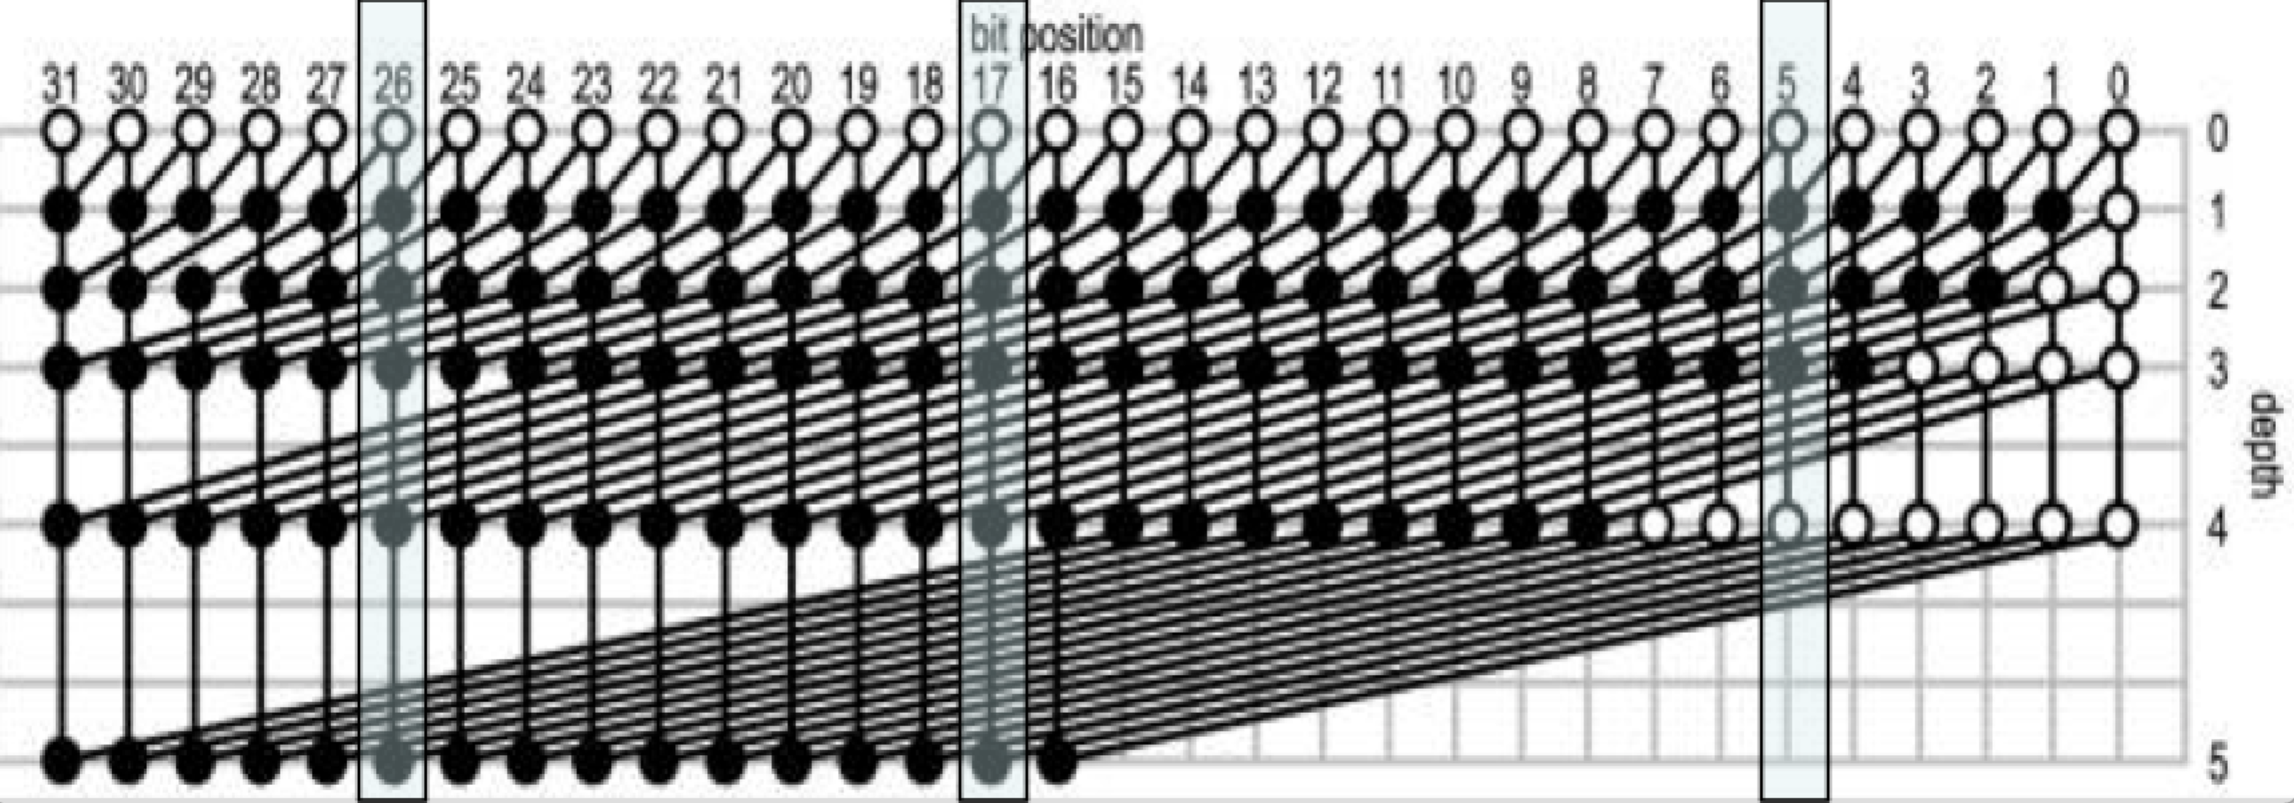
Once all of the half adder components in a standard adder are replaced with the modified component, we also need to add virtual ground connections to all of the gates. The virtual ground connections will be common among the gates in the same slice of the adder circuit. When one studies the construction of the prefix adder, it is clear that if a pair of input bits are both zero, all of the gates in the same slice as those input bits are not needed as they will simply compute zero anyway. We choose to perform power gating by establishing a virtual ground and using a footer switch instead of the header switch and virtual VDD for several reasons. It has been shown, as in [2], that footer switches generally incur less delay overhead for the same amount of power savings. Also, the OR outputs from the half adder can directly be used as gate inputs for footer switches which are connected to the common grounds of all of the gates in the adder slice. In this way, we will disable the entire slices of the circuits which are not needed for computation on every clock cycle.
Figure 9: Illustration of slices which can be disabled given certain zero input pairs
Figure 8: Modified half adder with OR output

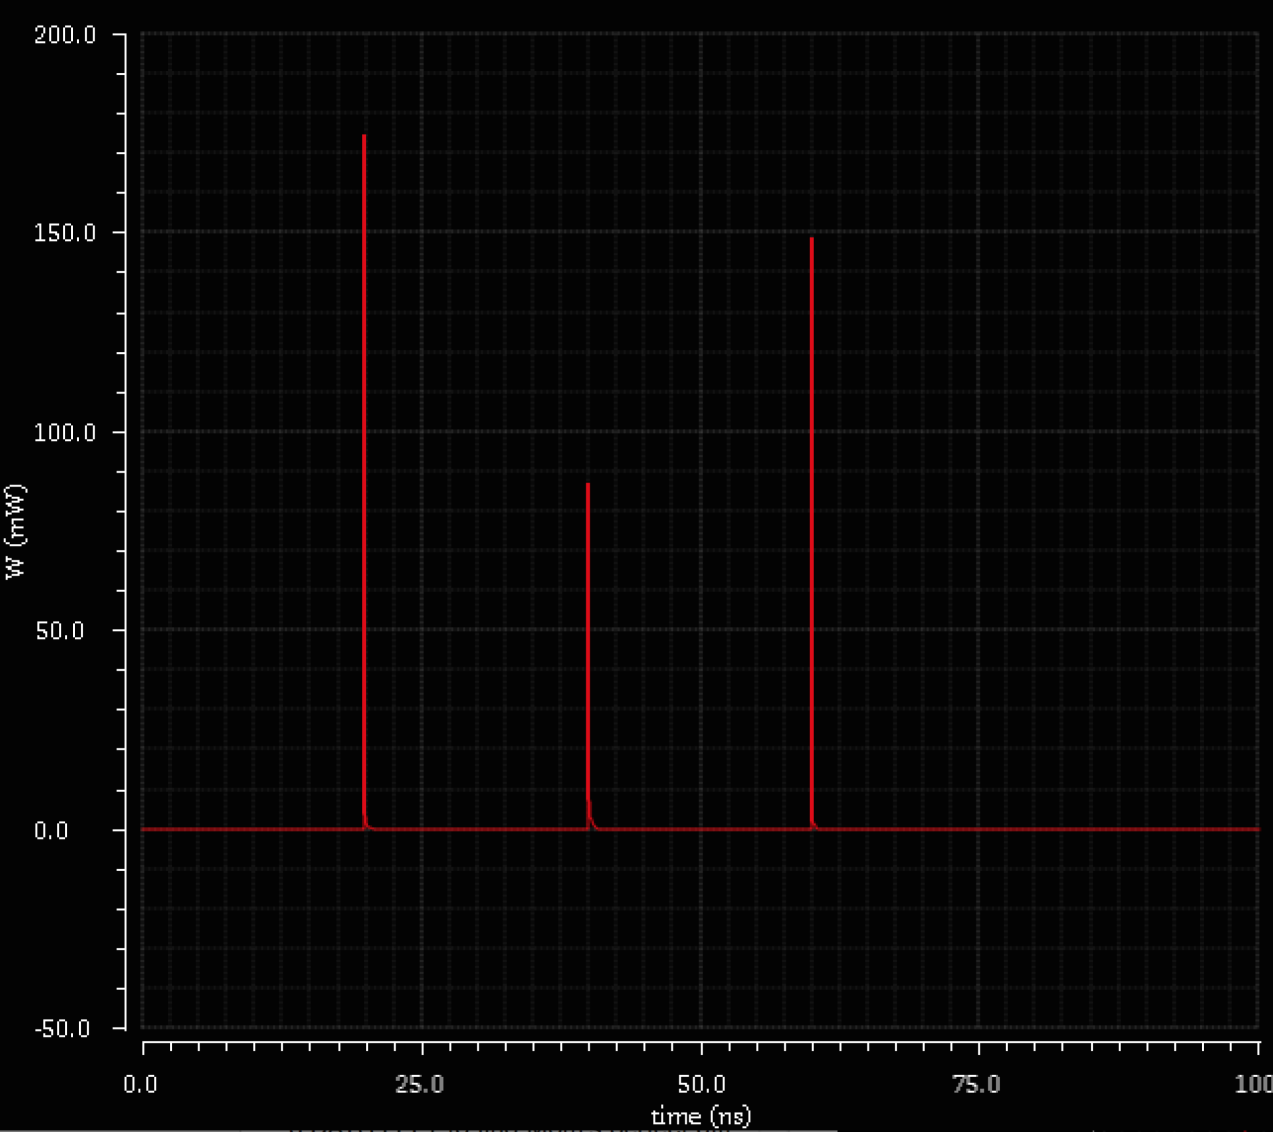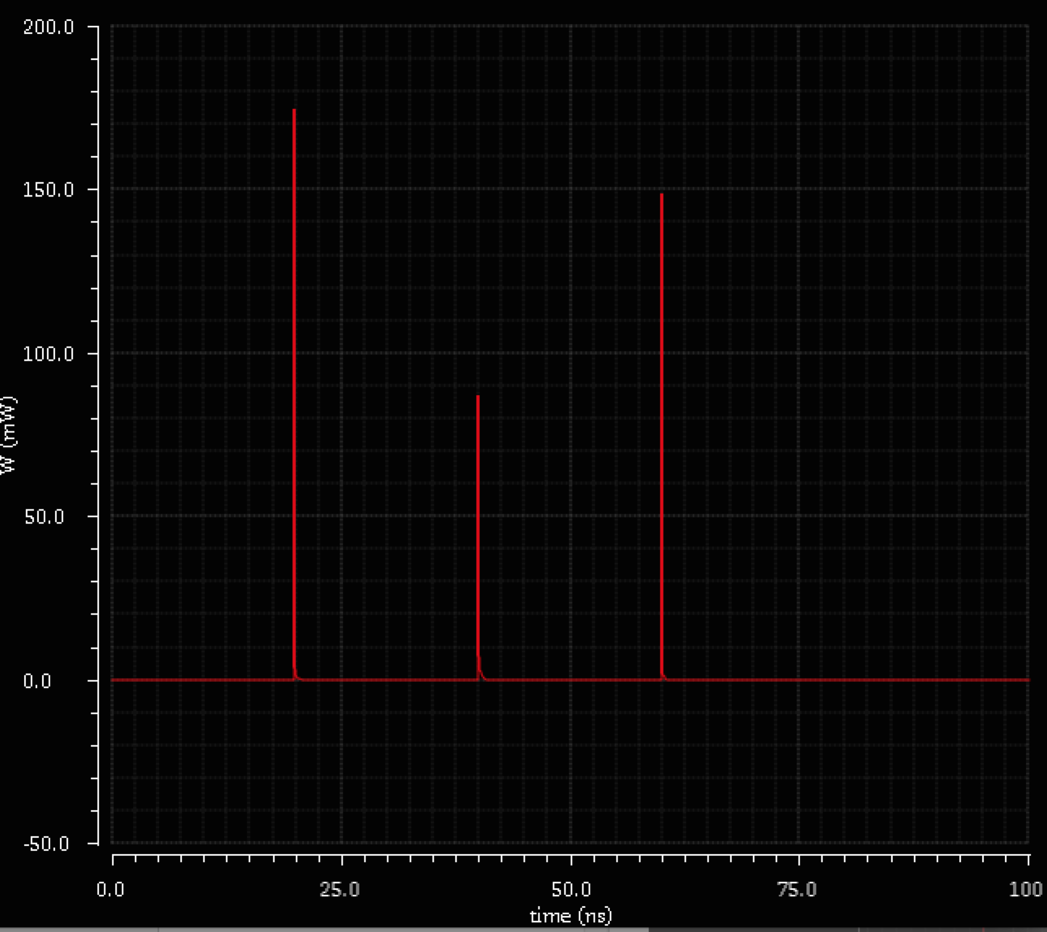
Figure 10: Power consumption without and with extra OR stage – total is 3.655pJ in either case

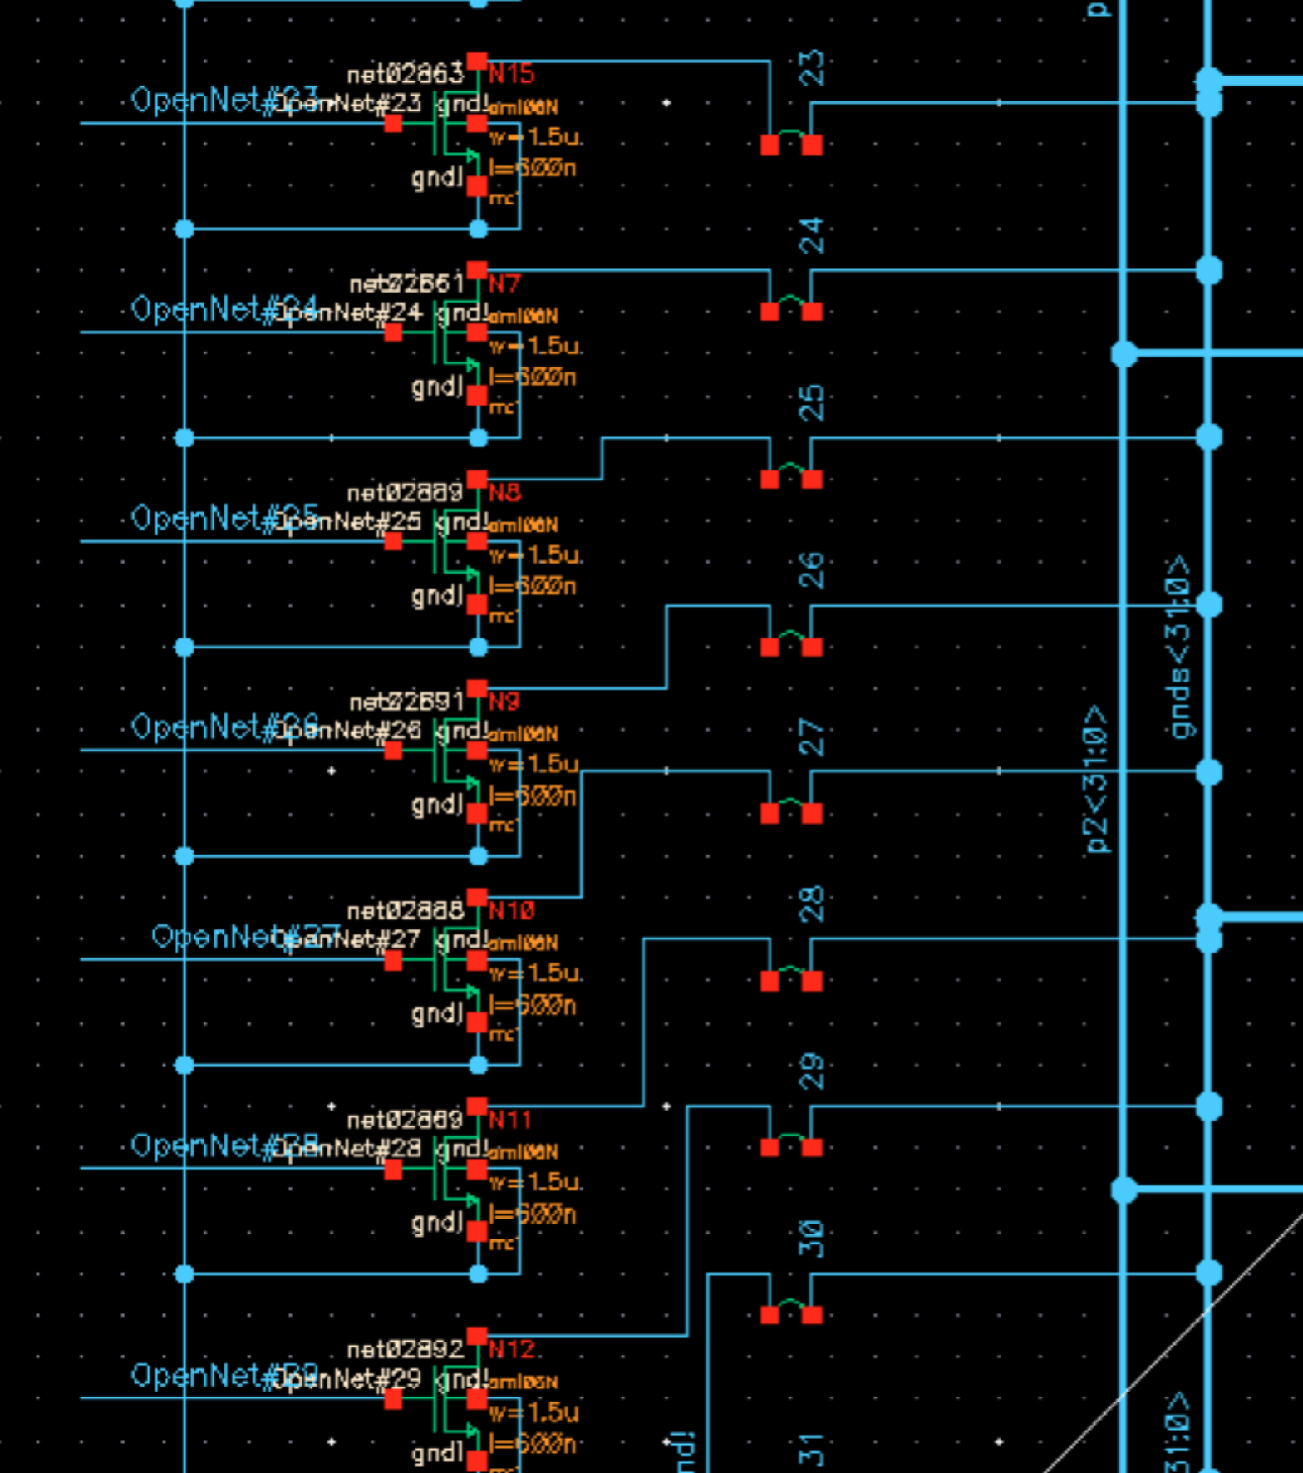
Modified power-gated adder design
A ground bus runs through all of the functional gates in the design, and connects the corresponding virtual ground to each gate in each bus. The termination of each line in the bus is connected to the footer switch. The ith footer switch has gate driven by the OR output from the ith input bit modified half-adder unit. In this way, whenever both input bits are zero, the OR signal will be zero as well, causing the nMOS footer switch to shut off and prevent the majority of the leakage power consumption.

We can then simulate the full adder with random input patterns to prove functionality. In order to characterize leakage power savings, we also simulate input patterns that have zero input bit pairs. We need to characterize the leakage power savings for each number of zero input bit pairs – power savings will be higher in this method if more of the input bit pairs are zero. Due to in-rush current issues, as discussed below, we only perform power gating on the most significant 16 bits.

Fig. 12 shows the full schematic of the power gated 32 bit Kogge-Stone adder.
Figure 11: footer switches connected to the corresponding ground bus line

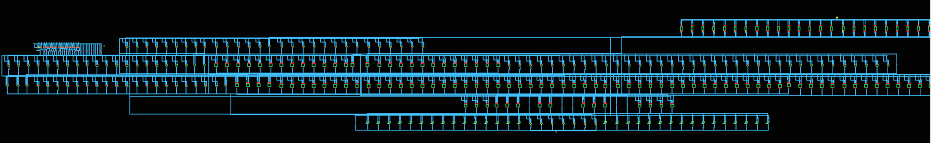
Ungated XOR output stage
Modified half adder stage
Virtual ground bus
Footer switch section
Figure 12: Full 32-bit Kogge Stone Adder schematic with 16 MSB footer switches

In-rush Current Challenges
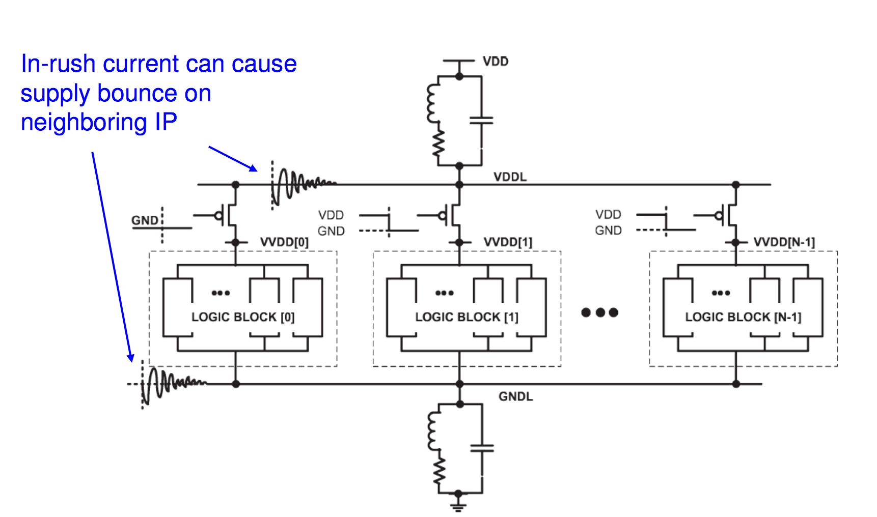
One commonly cited problem with power gating is the in-rush current. Because power gating isolates a module or a section of a module from the VDD and ground rails, once a module is to be woken up, the internal capacitances of the gates in the modules must also be recharged. [7] This causes a momentary but large current spike that can cause several problems. The general way to address this is to control the wake-up sequence so that many modules to not wake up simultaneously. We will discuss these problems and offer arguments that they are not issues in our design.

The first major problem is a ringing of the voltage supply rail. Because of the large current spike, if many components wake up at once, the entire VDD supply rail can ring and cause threshold issues with other more distant modules. However, this particular issue is generally a concern when a large number of devices awake at once. [8] In our design, we only allow for power gating on the most significant 16 bits. This alleviates the ringing issue by reducing the number of devices that could wake up at once, and by reducing the total amount of times that wake-ups should occur since the more significant bits are more likely to be sign extended bits with less overall changing.
Figure 13: In-rush current implications

The second issue is the wake up delay, which results from the actual time required to charge the capacitances back to operating voltage levels. [8] However, another benefit of only performing power gating on the upper half of the bits is that this the lower bit computations buy time for the more significant logic to re-awaken. As the power gating signals are computed immediately on input availability, a slice which is to be awoken has much more time to do so while the carry information propagates through the less significant slices. Thus, we do not notice a need for stalls when modules are awoken in this method.

Leakage power savings
After proving functionality, we simulated the modified adder over a fixed number of cycles in which $N$ input bit pairs were zero. We want to characterize the total amount of leakage power reduction as a function of the number of input pairs that are zero. We average the leakage power both with and without the power gating in place over the cycles to determine the savings. For example, the following results were observed when the 2 most significant bits were zero over the length of the cycle.

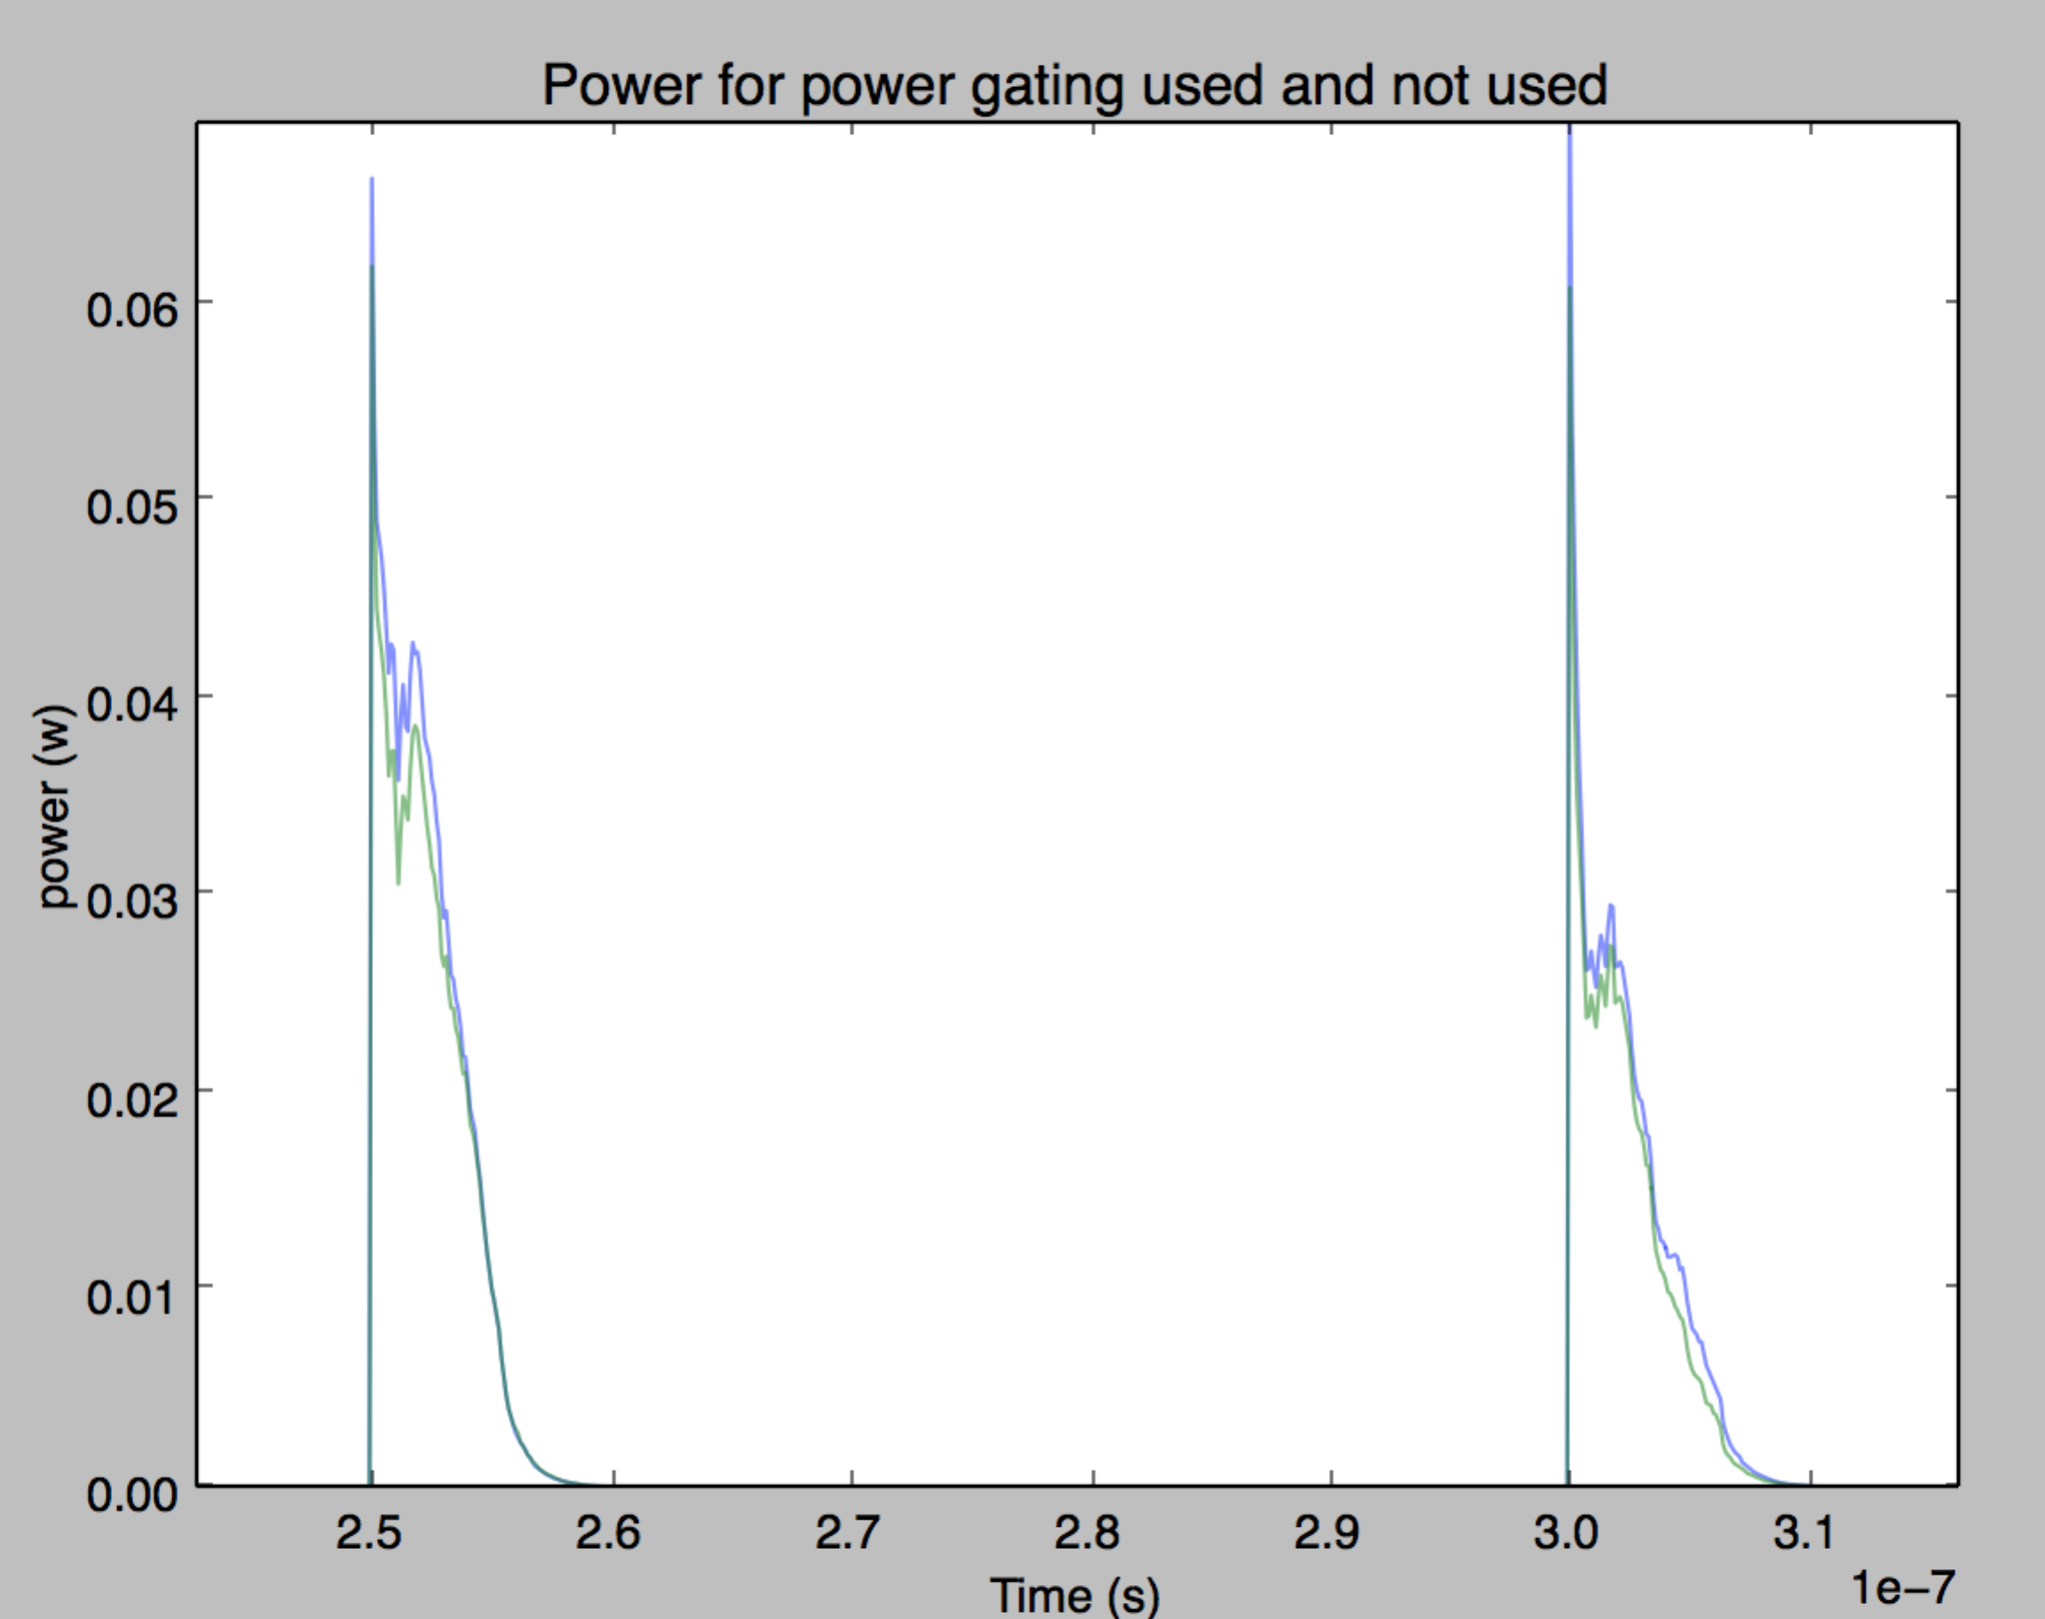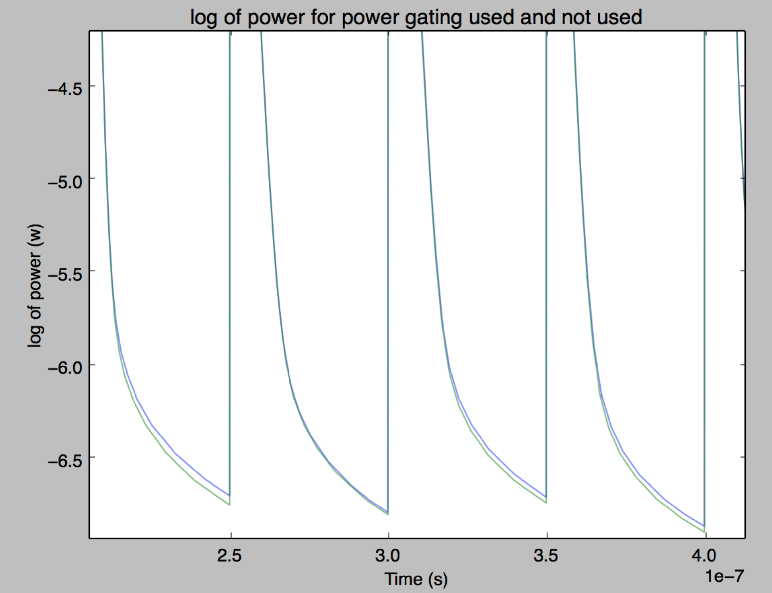
Figure 14: Power consumption with and without gating method for 2 MSB zero pairs, plotted on linear and log plot
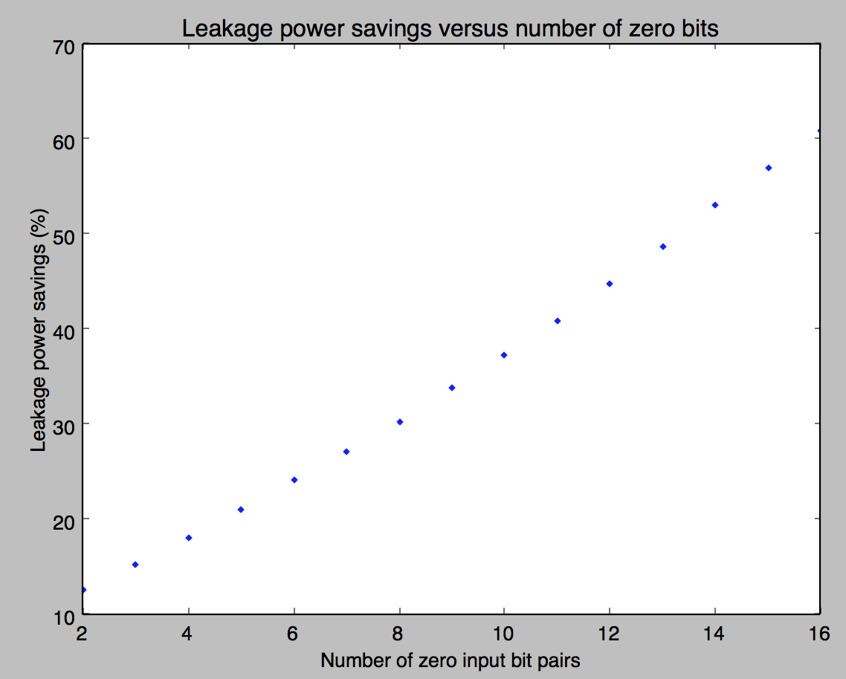
In Fig. 14, the leakage power reduction was 9%. Note that this is not the total power reduction, but the reduction in the “floor” power level – the leakage power.

This same process was repeated for most each number of MSBs up to 16 most significant bits all zero. We find the leakage power savings through the same averaging process, which yields the savings as indicated in Fig. 15. This makes sense intuitively, when one considers the structure of the prefix adder. The total amount of logic is slightly biased towards the higher order bits, which require slightly more gates to handle all of the carry conditions. Thus, when 16 MSBs input pairs are all zero, it makes sense that slightly over half of the leakage power should be reduced as the half of the circuit with slightly more logic is now being gated and should hardly leak at all.
Figure 15: Leakage power savings versus number of zero input bit pairs

Implementation and Simulation on GPGPU
While the static power savings using our method are promising, the true modern application for which they can be proved out is the GPGPU architecture, as mentioned. We will present or method implemented on a GPGPU architecture through the use of the GPGPU-Sim simulator and the GPUWattch power simulation engine. In the spirit of Yang’s work in [13], we will modify the power simulation model that computes leakage power while leaving the rest of the model untouched, and observe the total power savings on the ISPASS benchmark suite.

GPGPU-Sim and GPUWattch tools
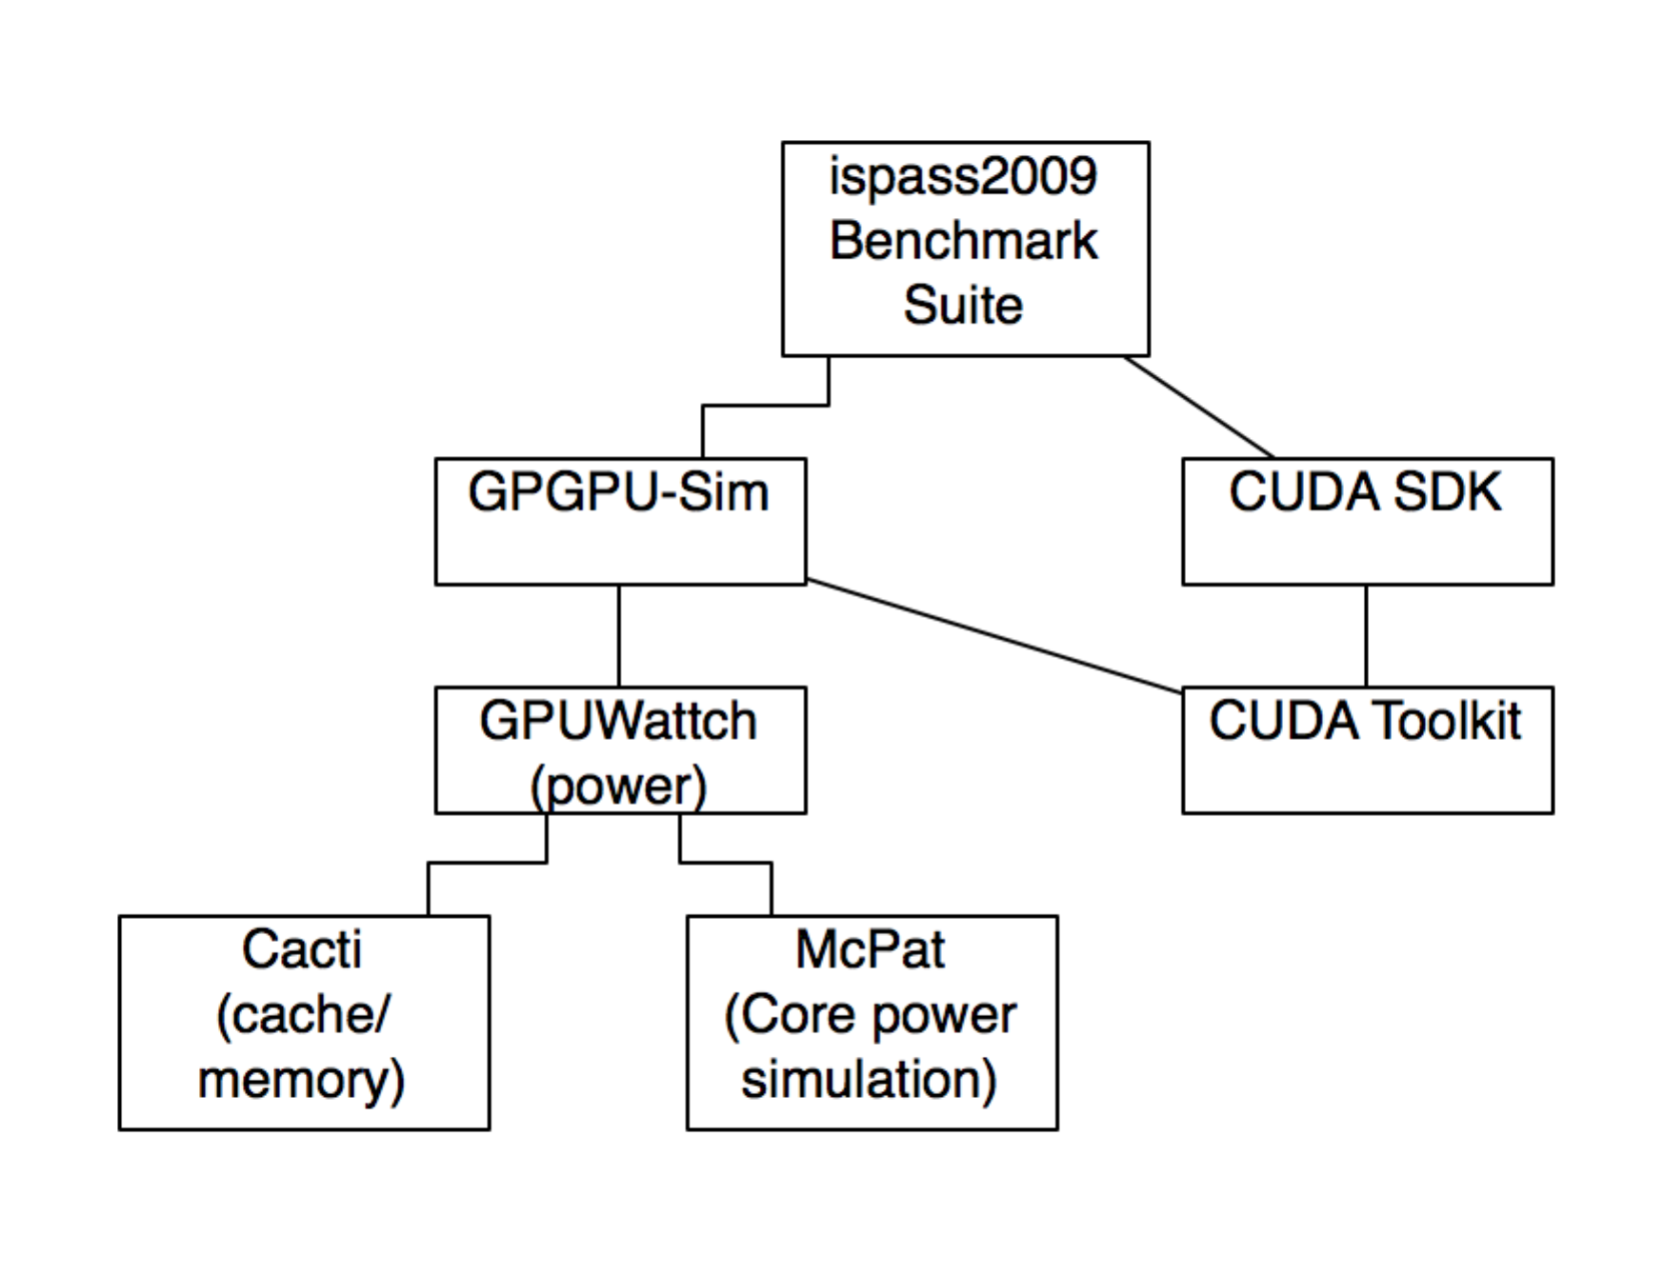
GPGPU-Sim was presented by Bakhoda, Yuan, Fung, and Wong in the IEEE 2009 Symposium on Performance Analysis of Systems and Software. [10] It is a commonly used simulator which can mimic a GPU for CUDA [4] and Open-CL (an alternative for CUDA not limited to nVidia hardware). It is generally used to evaluate timing, number of cycles, cache miss/hit rates, and other performance metrics. It comes together with GPUWattch, which was first disclosed in IEEE/ACM MICRO 2013. [11]. GPUWattch is built on the McPat and Cacti simulators, which model power consumption in processing unit cores and caches respectively. These tools have been widely used to model GPU performance and power consumption in various works, which seek to optimize these parameters. [8, 10-13]. Various studies have been done to validate the accuracy of these tools, and they generally perform within acceptable accuracy margins. [12]

Derivation of savings ratio
Figure 16: Software hierarchy of GPGPU-Sim as used with benchmarks
Fig. 15 indicates the amount of savings based on a number of bit input pairs being zero. However, this does not indicate how much power savings our method will produce on average. The GPUWattch model can only be modified at a high level, as leakage power is computed as each warp is processed. Fortunately, we can use Schulte’s work in [6] to get an idea how many instructions will actually have zero input operands.
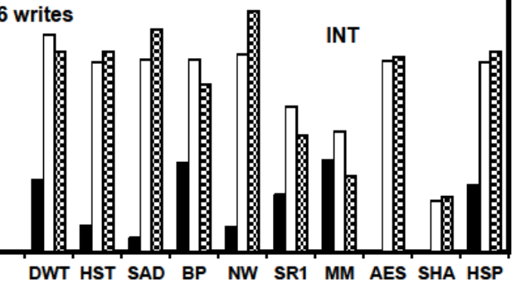
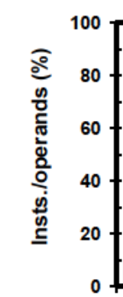

Figure 17: White bar: Percentage of instructions, which can be represented by 16 bits for each benchmark

Let the total power consumption of an integer core of an ALU in a GPU be $p$. GPUWattch calculates leakage power for this parameter.
Let us assume that by using the dynamic fine-grained power gating technique modeled in Cadence, we save the same ratio of power for the entire INT unit as in Fig. 15. Also, we will assume fairly that power savings will be linear over the 16MSBs in the arithmetic components. Call the values plotted in Fig. 15 $L_{i}$, $1≤i<16$ for $i$ zero bit input pairs. The ALU will consume the $L_{i}$ ratio of power whenever $i$ input pairs are zero. Call the probability that the $i$ MSB input pairs are zero $z_{i}$:

$$z_{i}=p\left(\bigcup_{j=32-i}^{32}{A_{j}=0 and B_{j}=0}\right)$$ | (3)
Based on Fig. 17, we can average the times that 16 input pairs were zero as the average heighten of the white bars, which turns out to be 0.64, so we conclude

$$z_{16}=0.64$$ | (4)

Without actually deriving these values, we can still approximate $z_{i} 1≤i<16$ by assuming these values linearly increase to 100% at $z_{0}$:

$$z_{i}=(1-z_{16})+\frac{z_{16}}{16}(i-16)$$ | (5)

We can now derive the new leakage power as a ratio of the original over these benchmarks – the leakage power consumed will be $p\left(1-L_{i}\right)$ when $i$ MSB input pairs are zero, which should happen $z_{i}-z_{i-1}$ percent of the time.

$$p^{'}=\left(\left(1-z_{16}\right)L_{16}+\sum_{i=1}^{15}{L_{i}\left(z_{i}-z_{i-1}\right)}\right)p=0.56p$$ | (6)
Thus, over the entire run of the benchmarks, we should save 44% of the leakage power consumed.

Modification of GPUWattch/McPAT power model
The power model in GPUWattch was modified to incorporate this leakage power reduction. The software hierarchy of these two simulators is outlined in Fig. 18.

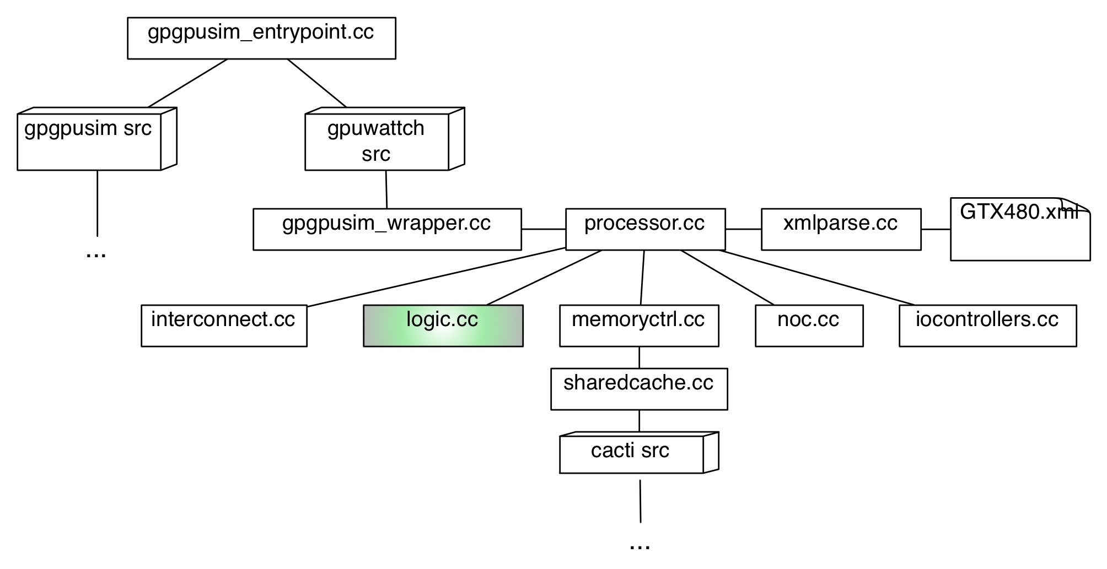
Figure 18: GPGPU-Sim and GPUWattch software hierarchy. Modifications to logic.cc
GPGPU-Sim and GPUWattch have source code in separate branches. We are interested in the GPUWattch source code. For each of the GPU cores, a “processor” object is created. This object has power which is modeled by various helper modules, which compute power consumption for the interconnects, the memory controllers, the IO controllers, NOC systems (if present) and the ALU/FPU core logic. We are interested in this last piece – the leakage power is computed in the logic.cc file for the ALU and FPU units. We modify the model to scale the leakage power consumption based on Eqn. 6 for ALU and FPU control. Note that we are assuming the FPU will have similar savings, and indeed according to [6], similar ratios of instructions will be expressible with 16 or fewer bits.
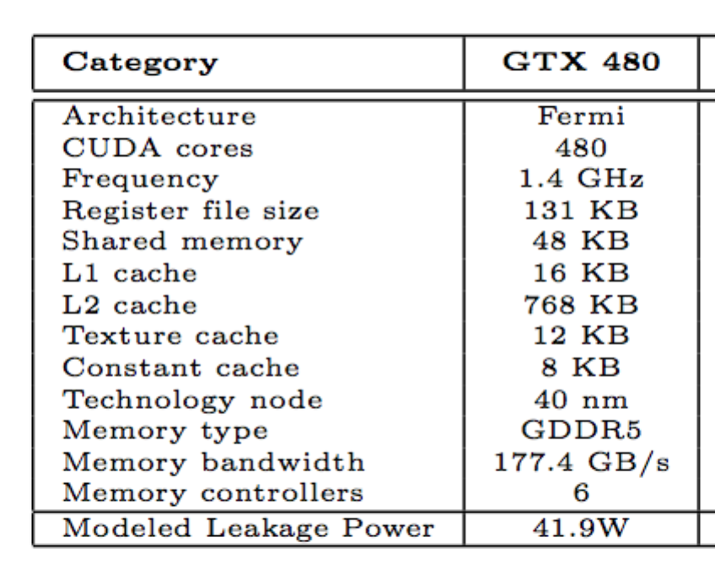
The leakage power is modeled in GPUWattch according to actual findings in [11] by the creators of GPUWattch. For the GTX480 nVidia GPU, they modeled leakage power as 41.9W and verified this model using actual hardware. As such, we use the outputs from the GPGPU-Sim power models and our modified leakage power model, and configured the simulators to use the GTX 480 reference model by selecting the corresponding XML file. Currently GPUWattch is only supported for this architecture, but it should represent a good approximation of GPU performance in general. [12]

We present our total savings in Fig. 20, with the assumption that we save power in ALU and FPU.
Figure 19: Total leakage power for GTX480 chipset

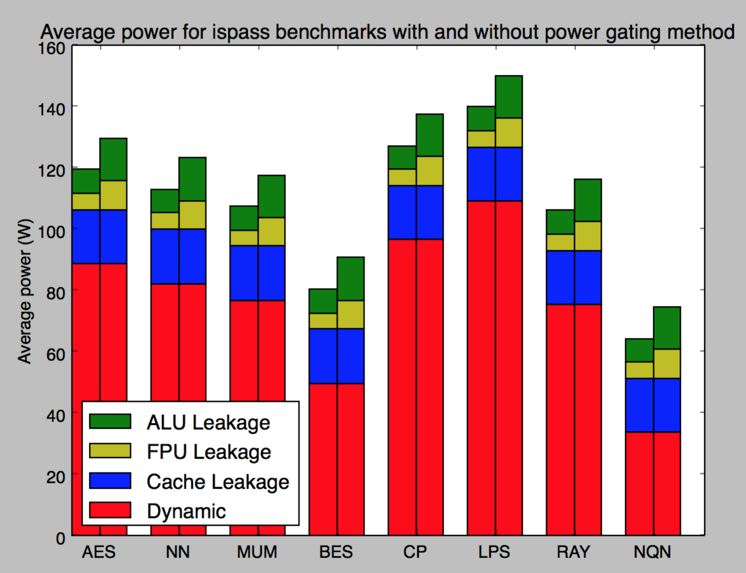
Base usage
Our method
Figure 20: Power consumption with and without power gating method
We note that our savings are high in terms of leakage. Still, dynamic power consumption can be quite high leading to overall lower percentages of savings. However, as technology develops, leakage power is becoming more and more of the total power consumption, as illustrated in Fig. 7. Also, using our method produces these savings essentially for free in terms of performance and just a small increase in area for the power gating logic. As we will discuss, this method could also be used in tandem with other power gating methods, but at a lower level, producing high savings.

Comparison to other methods

Savings of different power gating methods

Table 1 below presents the highly cited methods for savings on various platforms using similar power gating methods, both for CPU and GPU usage. We indicate the savings that the authors demonstrated, as well as what kind of application is discussed, to place our method’s performance.

Table 1: Comparison of power gating methods

Method | Authors | Platform | Type of power | Advertised savings
Clock gating portions of ALU | Brooks, Martonosi (2000)⁵ | CPU | Dynamic | 45-60%
Multiple datapaths based on zero inputs | Schulte, Kim, Gilani (2013)⁶ | GPGPU | Dynamic | 25%
Coarse-grained tournament prediction core power gating | Arora, Jayasena, Schulte, AMD (2015)¹⁵ | CPU | Static
Coarse-grained power gating on INT/FP units with gating aware scheduling | Abdel-Majeed, Wong, Annavaram (2013)¹⁴ | GPGPU | Static | 31%*
Value based individual cache array shutdown | Yang (2014)¹³ | GPGPU Cache | Static | 51%
Our Method |  | GPGPU | Static | 44%*
*Integer unit static power savings, average

We note that our method performs in line with many of the others. While we have not performed an exhaustive simulation of many different platforms, GPUWattch is well-regarded, and we believe it is likely that our method would perform well in comparison with the other methods.

Compound use with other methods
Due to our method being used at the lowest level far within the logic components of the devices, we can use other methods at the same time as our method. For example, we can use Schulte’s multiple data path approach for dynamic power savings and Wang’s cache GPGPU savings approach for cache leakage power savings. Compounding methods like this can results in total power savings of 35% of the total power consumption.

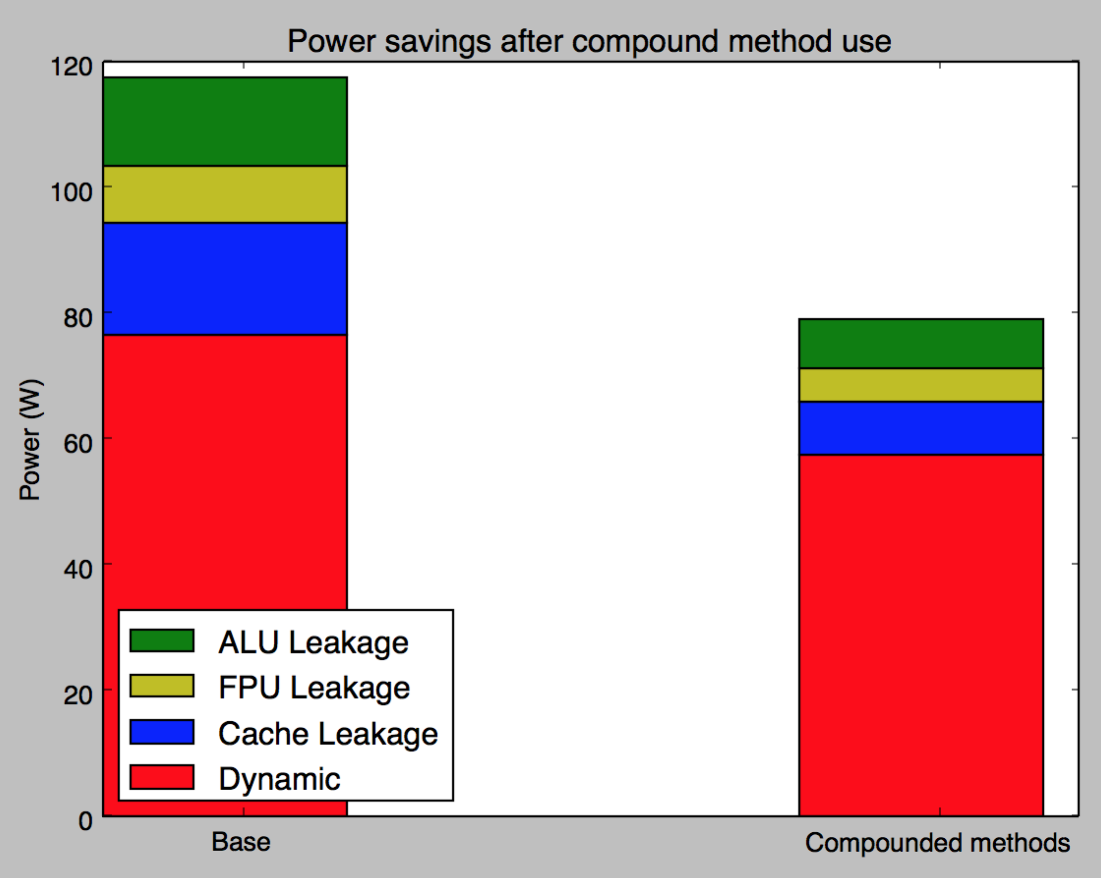
Figure 21: Power savings after compound method use
Fig. 21 was derived based on the average of the bars in Fig. 20. As each of these techniques are independent, all of the methods can contribute to the power savings, leading to substantial savings as a whole.

Conclusion
In the modern processor arena, with shrinking technologies, parallelism is becoming more and more common. At the same time, leakage power consumption is becoming more and more the leading type of power consumption. With thousands of cores, GPUs provide a great opportunity to save this leakage power by deactivating parts of the circuits not in use. A simple but largely effective modification to arithmetic circuits to shut off slices based on input bit pairs has been presented and shown to be effective on GPGPU applications by use of widely-used simulator platforms. The ability to compound this method with others in the literature makes it all the more effective.

References
- Henry, M, “Emerging Power-Gating Techniques for Low Power Digital Circuits,” Doctoral dissertation 2011, Virginia Polytechnic Institute, Blacksburg VA
- Hu, Z. Buyuktosunoglu, A. Srinivasan, V. IBM Watson Research Center, “Microarchitectural Techniques for Power Gating of Execution Units”, 2004 ACM ISLPED.
- Owens, J. Luebke, D. Govindaraju, N. Harris, M. A Survey of General Purpose Computation on Graphics Hardware. Eurographics 2005, State of the Art Reports, August 2005, pp. 21-51.
- NVIDIA’s Next Generation CUDA Compute Architecture: Fermi. White Paper, 2009 NVIDIA Corporation.
- Brooks, D. Martonosi, M. Value-Based Clock Gating and Operation Packing: Dynamic Strartegies for Improving Processor Power and Performance. ACM Transactions on Computer Systems, Vol. 18, No. 2, 2000, Pages 89–126.
- Schulte, M. Kim, N.S. Power-efficient computing for compute-intensive GPGPU applications. 2013 IEEE 19th International Symposium on High Performance Computer Architecture (HPCA2013)
- Teng, S.K. Power Gate Optimizaqtion Method for In-Rush Current and Power Up Time. Intel Corp, 2011.
- Kosonoky, S. Practical Power Gating and Dynamic Voltage/Frequency Scaling. AMD, Inc. 2011
- Suhwan Kim, Chang Jun Choi, Deog-Kyoon Jeong, Stephen Kosonocky, Sung Bae Park, Reducing Ground-Bounce Noise and Stabilizing the Data-Retention Voltage of Power-Gating Structures, IEEE Transactions on Electron Devices, Vol. 55, NO. 1, January 2008
- Bakhoda, A. Yuan, G. Fung, W. Wong, T. Aamodt, T. Analyzing CUDA Workloads Using a Detailed GPU Simulator. IEEE International Symposium on Performance Analysis of Systems and Software, 2009. ISPASS 2009.
- Leng, J. Hetherington, T. ElTanawy, A. Kin, N.S. GPUWattch: Enabling Energy Optimizations in GPGPUs. International Symposium on Computer Architecture (ISCA) 2013.
- Leng, J. Fung, W. Kim, N.S, “GPUWattch + GPGPU-Sim: An Integrated Framework for Performance and Energy Optimizations in Manycore Architectures” GPGPU-Sim/GPUWattch Tutorial (MICRO 2013).
- Wang, Y, “Performance and Power Optimization of GPU Architectures for General-purpose Computing”, Doctoral Dissertation 2014, University of South Florida.
- Abdel-Majeed, M. Wong, D. Annavaram, M. Warped gates: gating aware scheduling and power gating for GPGPUs. Proceedings of the 46th Annual IEEE/ACM International Symposium on Microarchitecture, 2013
- M. Arora, N. Jayasena, M. Schulte, “Prediction for power gating”, US Patent US 20150067357 A, 2015
- M. Arora, S. Manne, I. Paul, N. Jayasena, D. Tullsen, “Understanding idle behavior and power gating mechanisms in the context of modern benchmarks on CPU-GPU integrated systems”, 2015 IEEE International Symposium on High Performance Computer Architecture

